|  |  |  |  |  |
| --- | --- | --- | --- | --- |
|  |  | | |  |
|  |  | | |  |
|  | Function Group Spec  Profile Interface Client - FnG  <<Logical>> (Allocated) | | |  |
|  |  |
|  |  |
|  |  | | |  |
| Document Type | **Function Specification** | | |  |
| Template Version | **6.0** | | |  |
| SysML Report Template Version | **O Beta (11/6/2019)** | | |  |
| Document ID | **functionspec_sysmlreporttemplate** | | |  |
| Document Location |  | | |  |
| Document Owner | **Justin Bauer, Walter Stephens** | | |  |
| Document Revision | **FGS0** | | |  |
| Document Status | **Draft** | | |  |
| Date Issued | **2021-03-10** | | |  |
| Date Revised | **2021-03-10** | | |  |
| Document Classification | GIS1 Item Number: | **27.60/35** | |  |
| GIS2 Classification: | **Confidential** | |
|  | | | | |
|  | | | | |
| Document Approval | | | | |
| Name | Role | | Email Confirmation | Date |
|  |  | |  |  |
|  |  | |  |  |

Auto-Generated by MagicDraw

Printed Copies are Uncontrolled

# Disclaimer

**This document contains Ford Motor Company Confidential information. Disclosure of the information contained in any portion of this document is not permitted without the expressed, written consent of a duly authorized representative of Ford Motor Company, Dearborn, Michigan, U.S.A.**

**Copyright, Ó 2016 Ford Motor Company**

This document contains information developed and accumulated by and for FORD MOTOR COMPANY. As such, it is a proprietary document, which, if disseminated to unauthorized persons, would provide others with restricted information, data, or procedures not otherwise available, exposing the FORD MOTOR COMPANY to potential harm.

Employees and suppliers having custody of this specification or authorized to use it must be cognizant of its proprietary nature and ensure that the information herein is not made available to unauthorized persons.

FORD MOTOR COMPANY reserves the right to protect this work as an unpublished copyrighted work in the event of an inadvertent or deliberate unauthorized publication. FORD MOTOR COMPANY also reserves its rights under copyright laws to protect this work as a published work.

This document or portions thereof shall not be distributed outside FORD MOTOR COMPANY without prior written consent. Refer all questions concerning disclosure to the author(s) or to any duly authorized representative of Ford Motor Company.

# Contents

1.1.1 Decomposition of 4

Disclaimer 16

Contents 17

2 Introduction 19

2.1 Document Purpose 19

2.2 Document Scope 19

2.3 Document Audience 19

2.3.1 Stakeholder List 19

2.4 Document Organization 19

2.4.1 Document Context 19

2.4.2 Document Structure 19

2.5 Document Conventions 20

2.5.1 Requirements Templates 20

3 Function Group Description 21

4 Functional Architecture 22

4.1 Description 22

4.2 Function List 22

4.3 Signal List 22

5 Function Specifications 23

5.1  23

5.1.1 Function Overview 23

5.1.2 Function Scope 25

5.1.3 Function Interfaces 26

5.1.4 Function Modeling 28

5.1.5 Function Requirements 28

6 Open Concerns 32

7 Revision History 33

8 Appendix 34

8.1 Data Dictionary 34

8.1.1 Logical Signals 34

8.1.2 Logical Parameters 34

8.1.3 Encoding Types 34

8.2 Glossary 34

8.2.1 Definitions 34

8.2.2 Abbreviations 35

**List of Figures**

Figure 1 Activity diagram “” depicting black box behavior collaboration 22

Figure 2: Activity Diagram of “” calling “” 26

Figure 3: 28

**List of Tables**

Table 1: - Decomposition Table 5

Table 2: Functions described in this specification 19

Table 3: List of Logical Functions 22

Table 4: Ford internal Documents 25

Table 5: Ford internal Documents *(not specified in model)* 25

Table 6: External documents and publications 25

Table 7: External documents and publications *(not specified in model)* 25

Table 8: Open Concerns *(Not supported by MagicDraw report generation.)* 32

Table 9: Definitions used in this document 35

Table 10: Abbreviations used in this document 35

# Introduction

## Document Purpose

The Function (Group) Specification (FS) specifies an individual function / a group of functions.

To get more information about the concept of feature, function and component level abstraction refer to the [Ford RE Wiki](http://wiki.ford.com/display/RequirementsEngineering/Requirements+Engineering+for+SW+Enabled+Features).

## Document Scope

The following set of functions from the [Global Feature & Function List](https://www.vsemweb.ford.com:443/tc/launchapp?-attach=true&-s=226TCSession&-o=ZmZNi0JHx3NrTDAAAAAAAAAAAAA) is described in this specification.

|  |  |  |  |
| --- | --- | --- | --- |
| **Function ID** | **Function Name** | **Owner** | **Reference** |
|  | -1749448761.jpg Display Secondary Passcode Screen <<Subsystem Function>> |  |  |
|  | -1749448761.jpg Display Customize Profile Screen <<Subsystem Function>> |  |  |
| Fn012420/A | -1749448761.jpg Lockout Profile for Download <<Subsystem Function>> |  |  |
| Fn012434/A | -1749448761.jpg Setup Secondary Authentication - Passcode <<Subsystem Function>> |  |  |
| Fn012441/A | -1749448761.jpg Display Login Method <<Subsystem Function>> |  |  |
| Fn012449/A | -1749448761.jpg Display Authentication Status <<Subsystem Function>> |  |  |
| Fn012452/A | -1749448761.jpg Setup Primary Authentication <<Subsystem Function>> |  |  |
| Fn012454/A | -1749448761.jpg Display Option to Unlink FP Account <<Subsystem Function>> |  |  |
| Fn012456/A | -1749448761.jpg Display Welcome Screen with ID Method <<Subsystem Function>> |  |  |
| Fn012466/A | -1749448761.jpg Display Confirmation of Updated Profile <<Subsystem Function>> |  |  |
| Fn012470/A | -1785743972.jpg Display Error Messages <<Subsystem Function>> |  |  |

**Table 2: Functions described in this specification**

## Document Audience

The FS is authored by the owners of the individual functions. All Stakeholders, i.e., all people who have a valid interest in the functions and their behavior should read and, if possible, review the FS. It needs to be guaranteed, that all stakeholders have access to the currently valid version of the FS.

**#Hint:** The FS template has the IP Classification “Proprietary” by default. IP Classification “Confidential” might be required in some cases, e.g. by Ford Functional Safety.

### Stakeholder List

For the latest list of the feature stakeholder and their roles & responsibilities refer to [PPP Stakeholder List](https://www.vsemweb.ford.com/tc/launchapp?-attach=true&-s=226TCSession&-o=S5U9Hrgbx3NrTDAAAAAAAAAAAAA&servername=Production_Server)

**#Hint:** Refer to [Ford RE Wiki – Stakeholder List](http://wiki.ford.com/display/RequirementsEngineering/Stakeholder+Analysis) on how to create a stakeholder list. The stakeholder list should be stored in VSEM in the pseudo folder “General Data Artifacts” of the corresponding function.

## Document Organization

### Document Context

Refer to the [Specification Structure page](http://wiki.ford.com/display/RequirementsEngineering/Specification+templates) in the [Ford RE Wiki](http://wiki.ford.com/display/RequirementsEngineering/Requirements+Engineering+for+SW+Enabled+Features) to understand how the FS relates to other Ford Requirements Documents and Specifications.

### Document Structure

The structure of this document is explained below:

**Section 1** – Introduction how to use this document including responsibilities and requisite documents. Explains the terminology. Gives a clarification of the definitions, concepts and abbreviations used in the document.

**Section 2** – Function Group Description. Gives an overview and the purpose of the function group.

**Section 3** – Functional Architecture: Specifies the overall functional architecture of the function group

**Section 4** – Function Specifications: Specifies the logical functions of the function group in detail

**Section 5** – List of Open Concerns

**Section 6** Revision history including a list of new or modified requirements. The requirements in this document are tagged, and this section contains different types of tables listing all, new, or changed requirements by their title and page no.

**Section 7** – Appendix: Presenting additional data mainly in a tabular form, e.g., a data dictionary

**#Hint:** All sections are mandatory, unless explicitly marked by the tag “#Classification” as “optional” or as applicable e.g. to certain domains like “Functional Safety”.

## Document Conventions

### Requirements Templates

Each requirement, use case or scenario in this specification shall follow the corresponding template given in the document template *Specification_Macros.dotm* at [RE Wiki - Specification Templates](http://wiki.ford.com/display/RequirementsEngineering/Specification+templates?src=contextnavpagetreemode).

#### Identification of Requirements

#### Requirements Attributes

The templates provided by *Specification_Macros.dotm* define a list of attributes for each requirement. This helps to classify the requirement. The attributes are explained at [RE Wiki - Requirements Attributes](http://wiki.ford.com/display/RequirementsEngineering/Requirements+Attributes?src=contextnavpagetreemode).

# Function Group Description

**#Classification:** Function Group only (remove section, if only a single Function is specified in this document)

**#Hint**: Provide an overview / a description of the Function Group

This Function Group consists of all functions allocated to -1143646936.jpg **Profile Interface Client - FnG** <<Logical>> including all functions in their corresponding call trees.

Description of Profile Interface Client - FnG:

The Profile Interface Client is the subsystem that interfaces with the customer inside of the host vehicle. Any functionality that requires a display or an interaction with the customer isl be provided through this subsystem. The Profile Interface Client is also in charge of alerting the customer if there are any errors within the system.

# Functional Architecture

**#Classification:** Function Group only (remove section, if only a single Function is specified in this document)

**#Hint:** The Functional Architecture shall reflect the result of the functional decomposition for a given feature or parts of it.

Refer to the [*RE Wiki – Functional Decomposition*](http://wiki.ford.com/display/RequirementsEngineering/Functional+Analysis+and+Architecture) for some guidance on how to decompose a feature into functions, i.e., how to find the right functional partitioning for the function level. The functions shown here are those, which are specified in section 5 “Function Specifications”.

## Description

**#Hint:** Provide some informal description of the characteristics of the chosen architecture. Also give some graphical representation of the Functional Architecture. Either SysML Internal Block diagrams or [Data Flow Diagrams](http://wiki.ford.com/display/RequirementsEngineering/Data+Flow+Diagram?src=contextnavpagetreemode) could be used to depict such a Functional Architecture.

**#Link:** [*SysML – Internal Block Diagrams*](https://pd3.spt.ford.com/sites/SystemsEngineering/SEC/sysml-teamsite/SysML%20Wiki/Internal%20Block%20Diagram%20Basics.aspx) or [*RE Wiki - Data Flow Diagrams*](http://wiki.ford.com/display/RequirementsEngineering/Data+Flow+Diagram?src=contextnavpagetreemodehttp://wiki.ford.com/display/RequirementsEngineering/Data+Flow+Diagram?src=contextnavpagetreemode)

## Function List

|  |  |  |  |
| --- | --- | --- | --- |
| **Function ID** | **Function Name** | **Function Description** | **ASIL** |
|  | -1749448761.jpg Display Secondary Passcode Screen <<Subsystem Function>> | This function displays a screen that allows the user to enter their passcode. |  |
|  | -1749448761.jpg Display Customize Profile Screen <<Subsystem Function>> | This function displays a screen that provides the ability for the user to customize certain parameters/aspects of their profile. |  |
| Fn012420/A | -1749448761.jpg Lockout Profile for Download <<Subsystem Function>> | This function is allocated to the Profile Interface Client and provides an HMI graphic that locks out the HMI screen so that the customer cannot make any changes while the PPP feature is applying settings. |  |
| Fn012434/A | -1749448761.jpg Setup Secondary Authentication - Passcode <<Subsystem Function>> | This is an HMI function that receives the secondary authentication passcode from the user. This function is executed when primary authentication of a user is unavailable or fails. |  |
| Fn012441/A | -1749448761.jpg Display Login Method <<Subsystem Function>> | This is an HMI function that is displayed to collect user credentials from the user. The credentials are used to authenticate a user in order to link their profile to their FordPass account and import their profile settings. |  |
| Fn012449/A | -1749448761.jpg Display Authentication Status <<Subsystem Function>> | The function is allocated to the Profile Interface Client which is inside the vehicle. This is an HMI function that will display the authentication status to a customer that is attempting to login to the vehicle. |  |
| Fn012452/A | -1749448761.jpg Setup Primary Authentication <<Subsystem Function>> | This is an HMI function that allows the user to setup their primary authentication method for their profile. |  |
| Fn012454/A | -1749448761.jpg Display Option to Unlink FP Account <<Subsystem Function>> | HMI function that provides the capability for the user to link their FP account to any pre-existing vehicle profiles. |  |
| Fn012456/A | -1749448761.jpg Display Welcome Screen with ID Method <<Subsystem Function>> | This function is used during the Remote Vehicle Setup (RVS) scenario and is allocated to the Profile Interface Client. This function displays a welcome screen to the customer and provides a method for the customer to provide positive ID. |  |
| Fn012466/A | -1749448761.jpg Display Confirmation of Updated Profile <<Subsystem Function>> | An HMI function that is used to communicate the status of an updated profile to the customer. |  |
| Fn012470/A | -1785743972.jpg Display Error Messages <<Subsystem Function>> | This function communicates error messages from other functions to the user. |  |

Table 3: List of Logical Functions

## Signal List

Refer to the Data Dictionary - Logical Signals.

# Function Specifications

## -1749448761.jpg Display Authentication Status

### Function Overview

#### Description

**#Hint:** Some descriptive text to explain the purpose and functionality of the function.

Function is allocated to:

* -361410294.jpg Display Authentication Status - APIM <<Subsystem Function>>
* -1143646936.jpg Profile Interface Client - FnG <<Logical>>

The function is allocated to the Profile Interface Client which is inside the vehicle. This is an HMI function that will display the authentication status to a customer that is attempting to login to the vehicle.

#### Variants

**#Classification**: Mandatory (State “Not applicable”, if not used)

**#Hint:** If different variants of the same function are specified in this section, list those variants in the table below.

Variants on Function level could be driven technology or feature content. Example: There could be a “Low Content” and a “High Content” variant of some exterior lighting function. The Low Content variant applies for Conventional Headlight technology, the High Content variant applies for LED and Xenon technology. In this case we call the different technologies the Variant Options (for the time being you could think of them as Logical Parameters) which the Variant depends on. The optional column “Variant condition” allows to express the dependency of a Variant based on Variant Options/Logical Parameters.

If requirements/signals are not applicable for all variants/variant options, those requirements should state explicitly, which function variant/variant option they apply to.

**#Link:** [RE Wiki – Variant Management](http://wiki.ford.com/display/RequirementsEngineering/Variant+Management).

*Not supported by MagicDraw report generation.*

#### Input Requirements

**#Classification**: Mandatory (State “Not applicable”, if not used)

**#Hint:** List any input requirements here (legal, Trustmark), which need to be taken into account, beyond what is specified in the corresponding Feature Documents.

*Not supported by MagicDraw report generation.*

#### Assumptions

**#Classification**: Mandatory (State “Not applicable”, if not used)

**#Hint:** A list of known assumptions concerning the effects of the function’s behavior on other functions or elements (i.e., dependencies) as well as assumptions on the behavior expected by the function (e.g. known limitations). During the course of the development most of those assumptions are typically either converted into actual requirements or discarded at some point – such that this chapter remains mostly empty.

No assumptions specified for this function.

#### References

##### Ford Documents

List here all Ford internal documents, which are directly related to the feature.

| **Reference** | **Title** | **Doc. ID** | **Revision** |
| --- | --- | --- | --- |
|  |  |  |  |

Table 5: Ford internal Documents *(not specified in model)*

##### External Documents and Publications

The list of external documents could include books, reports and online sources.

**#Hint:** You may refer to [IEEE Citation Reference](http://www.ieee.org/documents/ieeecitationref.pdf) on how to format a reference.

| **Reference** | **Document / Publication** |
| --- | --- |
|  |  |

Table 7: External documents and publications *(not specified in model)*

#### Glossary

See Appendix for Definitions and Abbreviations.

### Function Scope

The -1749448761.jpg **– “Display Authentication Status”** function is called by the following functions:

* -2062184996.jpg – “9 Recall Profile and ID User”
* -1336703069.jpg – “Identify Profile Owner”
* -1336703069.jpg – “Link FordPass Account with In-Vehicle Profile”

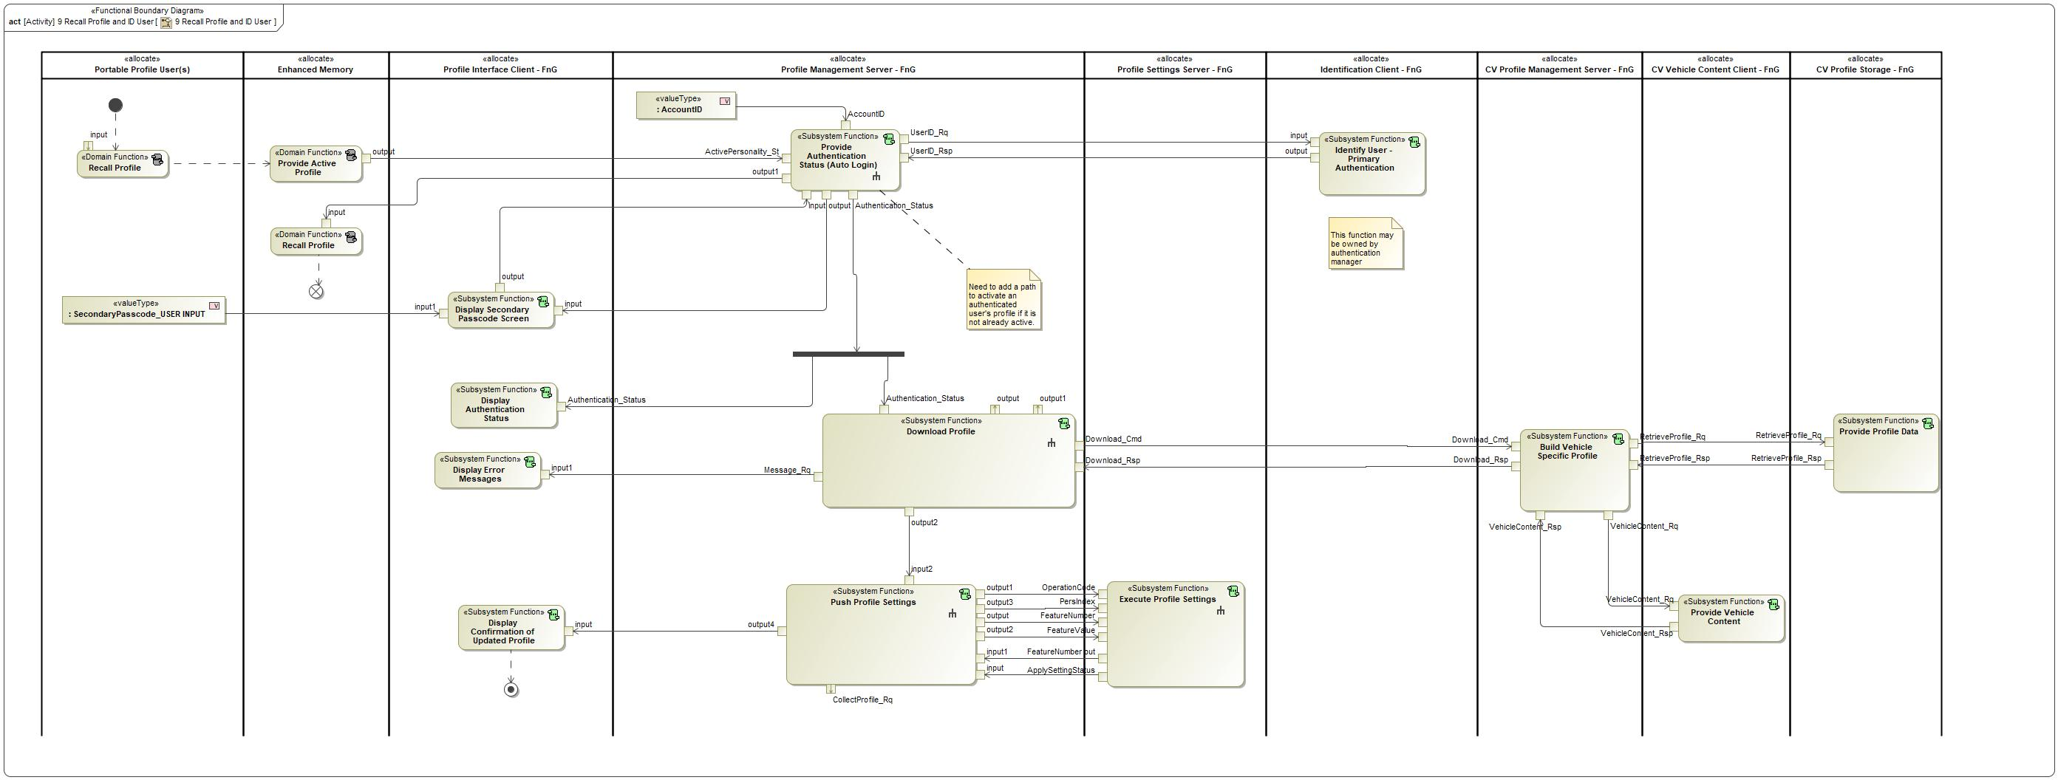

Figure : Activity Diagram of -2062184996.jpg “9 Recall Profile and ID User” calling -1749448761.jpg “Display Authentication Status”

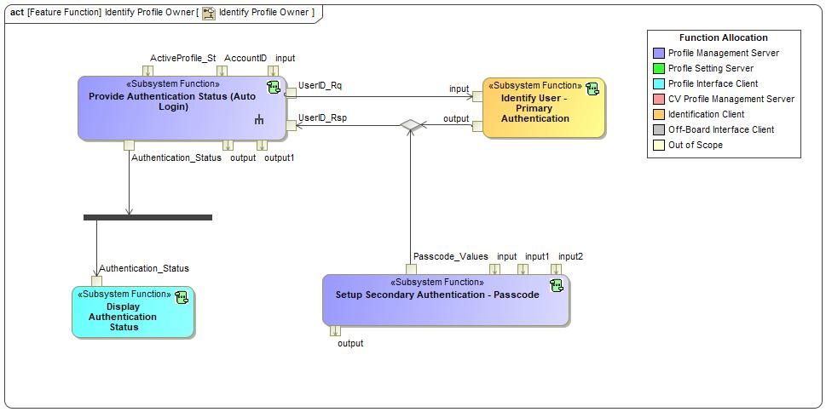

Figure : Activity Diagram of -1336703069.jpg “Identify Profile Owner” calling -1749448761.jpg “Display Authentication Status”

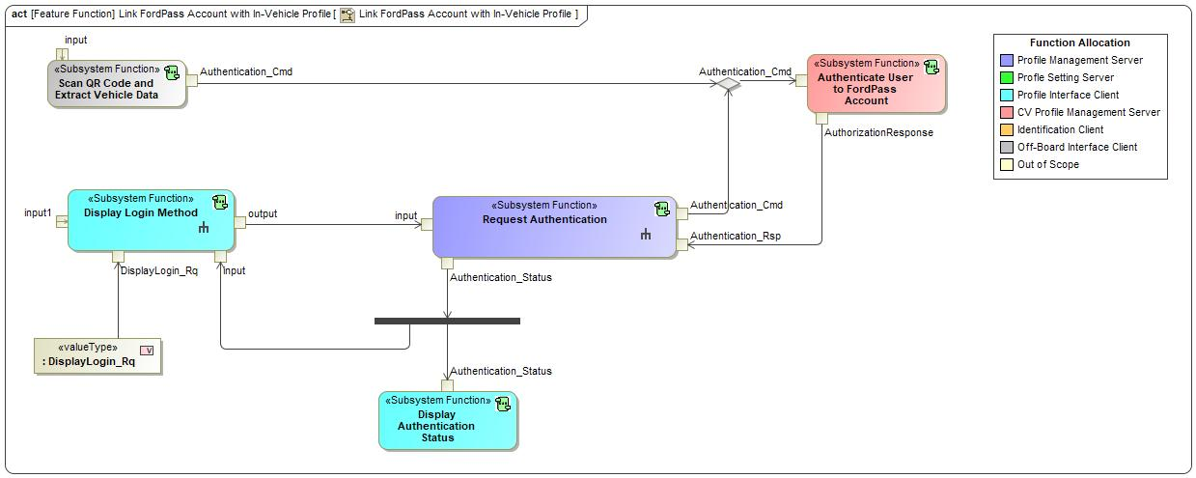

Figure : Activity Diagram of -1336703069.jpg “Link FordPass Account with In-Vehicle Profile” calling -1749448761.jpg “Display Authentication Status”

### Function Interfaces

**#Link:** [RE Wiki – Adding a Logical Signal or Parameter](http://wiki.ford.com/display/RequirementsEngineering/Adding+a+Logical+Signal+or+Parameter)

#### Logical Inputs

|  |  |
| --- | --- |
| **Signal Name** | **Description** |
| Authentication_Status  Type:  1791080190.jpg Authentication_Status | Signal Description:  Internal vehicle status that broadcasts if a profile is authenticated or not.  Received from:   * -1749448761.jpg Request Authentication * -1749448761.jpg Provide Authentication Status (Auto Login) |

#### Logical Outputs

No Logical Outputs specified.

#### Logical Parameters

**#Hint**: Put requirements for parameters here, which are implemented as configuration parameters using Method 2 or 3 or as parameters for calibration.

*Not supported by MagicDraw report generation.*

### Function Modeling

**#Classification:** Mandatory

**#Hint:** Typical modeling artifacts in this section are State Machines, Activity Diagrams / Flow Charts, Decision Tables, and possibly Sequence Diagrams, which can all be used as techniques to analyze the function requirements.

**#Links:** Analyze / Model Requirements: [RE Wiki – Analyze / Model Requirements](http://wiki.ford.com/pages/viewpage.action?pageId=110594919&src=contextnavpagetreemode)

#### Use Cases

**#Classification:** Infotainment Only (remove section, if not used)

**#Hint:** Some Domains (e.g. Infotainment) use not only Customer Use Cases (in the Feature Doc), but refine Use Case descriptions down to function level. In general, the RE approach encourages the use of Use Cases on Feature Level but not on Function Level. Activity Diagrams are a more suitable way to express the same on Function Level.

**#Links:** Infotainment – “Harmony Systems Engineering” Approach

*Not supported by MagicDraw report generation.*

#### State Charts / Activity Diagrams / Sequence Diagrams / Decision Tables

**#Classification:** Mandatory

**#Hint:** It is highly recommended to use at least one of the following modeling techniques for modeling and analyzing the Function behavior and derived requirements (refer to sample diagrams below):

State Machines, Activity Diagrams / Flow Charts, or Decision Tables

Optionally, Sequence Diagrams might help to analyze the interaction between Functions.

**#Links:** Analyze / Model Requirements: [RE Wiki – Analyze / Model Requirements](http://wiki.ford.com/pages/viewpage.action?pageId=110594919&src=contextnavpagetreemode)

State Charts [RE Wiki – State Charts](http://wiki.ford.com/display/RequirementsEngineering/State+Charts?src=contextnavpagetreemode)

Activity Diagrams: [RE Wiki – Activity Diagram](http://wiki.ford.com/display/RequirementsEngineering/Activity+Diagram?src=contextnavpagetreemode), [SysML User Group – Activity Diagram Basics](https://pd3.spt.ford.com/sites/SystemsEngineering/SEC/sysml-teamsite/SysML%20Wiki/Activity%20Diagram%20Basics.aspx)

Sequence Diagrams: [RE Wiki – Sequence Chart](http://wiki.ford.com/display/RequirementsEngineering/Sequence+Chart?src=contextnavpagetreemode), [SysML User Group – Sequence Diagram Basics](https://pd3.spt.ford.com/sites/SystemsEngineering/SEC/sysml-teamsite/SysML%20Wiki/Sequence%20Diagram%20Basics.aspx)

No diagrams internal to function specified.

### Function Requirements

#Link: [*RE Wiki – How to write good requirements*](http://wiki.ford.com/display/RequirementsEngineering/How+to+write+better+requirements?src=contextnavpagetreemode)

#### Functional Requirements

***#Hint:*** *Please also consider specific situations like Initialization (Startup) and Deinitialization (Shutdown) apart from Normal Operation and Error Handling. E.g. a* state chart or activity diagram might help for better understanding.

##### Normal Operation

REQ-405770/A Display Successful Login

When the Profile Interface Client receives a successful Authentication_Status, the Profile Interface Client shall display to the customer that the login was successful.

|  |  |  |  |  |  |  |  |
| --- | --- | --- | --- | --- | --- | --- | --- |
| Requirement ID: REQ-405770/A | | | | | | | |
| **Rationale** |  | | | | | | |
| **Acceptance Criteria** |  | | | | | | |
| **Notes** |  | | | | | | |
| **Source** |  | | | | | **Owner** |  |
| **Source Req.** |  | | | | | **V&V Method** |  |
| **Type** |  | | | **Priority** |  | **Status** |  |
| [Req. Template](http://wiki.ford.com/display/RequirementsEngineering/Requirements+Attributes) Version | | 6.0 | End of Requirement | | | | |

REQ-405771/A Duration of Authentication Status

After receiving the Authentication_Status from the Profile Management Server, the Profile Interface Client shall display the status to the user for XX seconds before moving to the next screen.

|  |  |  |  |  |  |  |  |
| --- | --- | --- | --- | --- | --- | --- | --- |
| Requirement ID: REQ-405771/A | | | | | | | |
| **Rationale** |  | | | | | | |
| **Acceptance Criteria** |  | | | | | | |
| **Notes** |  | | | | | | |
| **Source** |  | | | | | **Owner** |  |
| **Source Req.** |  | | | | | **V&V Method** |  |
| **Type** |  | | | **Priority** |  | **Status** |  |
| [Req. Template](http://wiki.ford.com/display/RequirementsEngineering/Requirements+Attributes) Version | | 6.0 | End of Requirement | | | | |

##### Error Handling

***#Hint:*** *FMEA counter measures could be considered as requirements in this chapter*

No Error Handling Requirements specified.

#### Non-Functional Requirements

***#Hint:*** *Non-functional requirements specify some performance criteria in addition to the functional behavior given defined by the functional requirements. Timing (if not already included in the functional requirements), security details (e.g. how secure does an algorithm have to be) or reliability (e.g. mean time between failure) could be specified in this section.*

No Non-Functional Requirements specified.

#### Functional Safety Requirements

**#Classification**: Functional Safety only – If not used, remove content and state “Not Applicable”

***#Hint:*** *Add Functional Safety Requirements (FSRs) derived for this function.*

**#Link:** [Functional Safety Sharepoint](https://pd3.spt.ford.com/sites/GlobalFunctionalSafety/Pages/default.aspx) – Functional Safety Concept

[RE Wiki - Requirements Attributes](http://wiki.ford.com/display/RequirementsEngineering/Requirements+Attributes)

No Functional Safety Requirements specified.

##### ASIL Decomposition of Functional Safety Requirements

**#Classification**: Functional Safety only – If not used, remove content and state “Not Applicable”

***#Hint:*** *Sometimes an ASIL decomposition of Functional Safety Requirements is required. The decomposed FSRs should be listed beneath each ASIL Decomposition table below and referenced inside the table by ID and Title*

**#Link:** [Functional Safety Sharepoint](https://pd3.spt.ford.com/sites/GlobalFunctionalSafety/Pages/default.aspx) – Functional Safety Concept

No Functional Safety Requirements with ASIL Decompositions specified.

#### Other Requirements

##### Design Requirements

***#Hint:*** *Requirements of a Logical Function should be typically agnostic of their SW/HW implementation*. If for specific reasons the function owner needs to define explicitly design constraints, it can be done in this chapter.

No Design Requirements specified.

## -1749448761.jpg Display Confirmation of Updated Profile

### Function Overview

#### Description

Function is allocated to:

* -361410294.jpg Display Confirmation of Updated Profile - APIM <<Logical>>
* -1143646936.jpg Profile Interface Client - FnG <<Logical>>

An HMI function that is used to communicate the status of an updated profile to the customer.

#### Variants

*Not supported by MagicDraw report generation.*

#### Input Requirements

*Not supported by MagicDraw report generation.*

#### Assumptions

No assumptions specified for this function.

#### References

##### Ford Documents

List here all Ford internal documents, which are directly related to the feature.

| **Reference** | **Title** | **Doc. ID** | **Revision** |
| --- | --- | --- | --- |
|  |  |  |  |

Table 5: Ford internal Documents *(not specified in model)*

##### External Documents and Publications

The list of external documents could include books, reports and online sources.

| **Reference** | **Document / Publication** |
| --- | --- |
|  |  |

Table 7: External documents and publications *(not specified in model)*

#### Glossary

See Appendix for Definitions and Abbreviations.

### Function Scope

The -1749448761.jpg **– “Display Confirmation of Updated Profile”** function is called by the following functions:

* -2062184996.jpg – “9 Recall Profile and ID User”



Figure : Activity Diagram of -2062184996.jpg “9 Recall Profile and ID User” calling -1749448761.jpg “Display Confirmation of Updated Profile”

### Function Interfaces

#### Logical Inputs

|  |  |
| --- | --- |
| **Signal Name** | **Description** |
| input  Type:  1791080190.jpg UpdateConfirmation_Rq | Signal Description:  Request to the Profile Interface Client to display a profile update confirmation to the user.  Received from:   * -1749448761.jpg Push Profile Settings |

#### Logical Outputs

No Logical Outputs specified.

#### Logical Parameters

*Not supported by MagicDraw report generation.*

### Function Modeling

#### Use Cases

*Not supported by MagicDraw report generation.*

#### State Charts / Activity Diagrams / Sequence Diagrams / Decision Tables

No diagrams internal to function specified.

### Function Requirements

#### Functional Requirements

##### Normal Operation

No Normal Operation Requirements specified.

##### Error Handling

No Error Handling Requirements specified.

#### Non-Functional Requirements

No Non-Functional Requirements specified.

#### Functional Safety Requirements

No Functional Safety Requirements specified.

##### ASIL Decomposition of Functional Safety Requirements

No Functional Safety Requirements with ASIL Decompositions specified.

#### Other Requirements

##### Design Requirements

No Design Requirements specified.

## -1749448761.jpg Display Customize Profile Screen

### Function Overview

#### Description

Function is allocated to:

* -361410294.jpg Display Customize Profile Screen - APIM <<Logical>>
* -1143646936.jpg Profile Interface Client - FnG <<Logical>>

This function displays a screen that provides the ability for the user to customize certain parameters/aspects of their profile.

#### Variants

*Not supported by MagicDraw report generation.*

#### Input Requirements

*Not supported by MagicDraw report generation.*

#### Assumptions

No assumptions specified for this function.

#### References

##### Ford Documents

List here all Ford internal documents, which are directly related to the feature.

| **Reference** | **Title** | **Doc. ID** | **Revision** |
| --- | --- | --- | --- |
|  |  |  |  |

Table 5: Ford internal Documents *(not specified in model)*

##### External Documents and Publications

The list of external documents could include books, reports and online sources.

| **Reference** | **Document / Publication** |
| --- | --- |
|  |  |

Table 7: External documents and publications *(not specified in model)*

#### Glossary

See Appendix for Definitions and Abbreviations.

### Function Scope

The -1749448761.jpg **– “Display Customize Profile Screen”** function is called by the following functions:

* -2062184996.jpg – “1 Link New Vehicle Profile w/ FP Account”
* -2062184996.jpg – “2 Link Pre-existing Vehicle Profile w/ FP account”
* -2062184996.jpg – “6 Unlink Vehicle Profile From FP Account”
* -1336703069.jpg – “Create Cloud Profile From Vehicle”

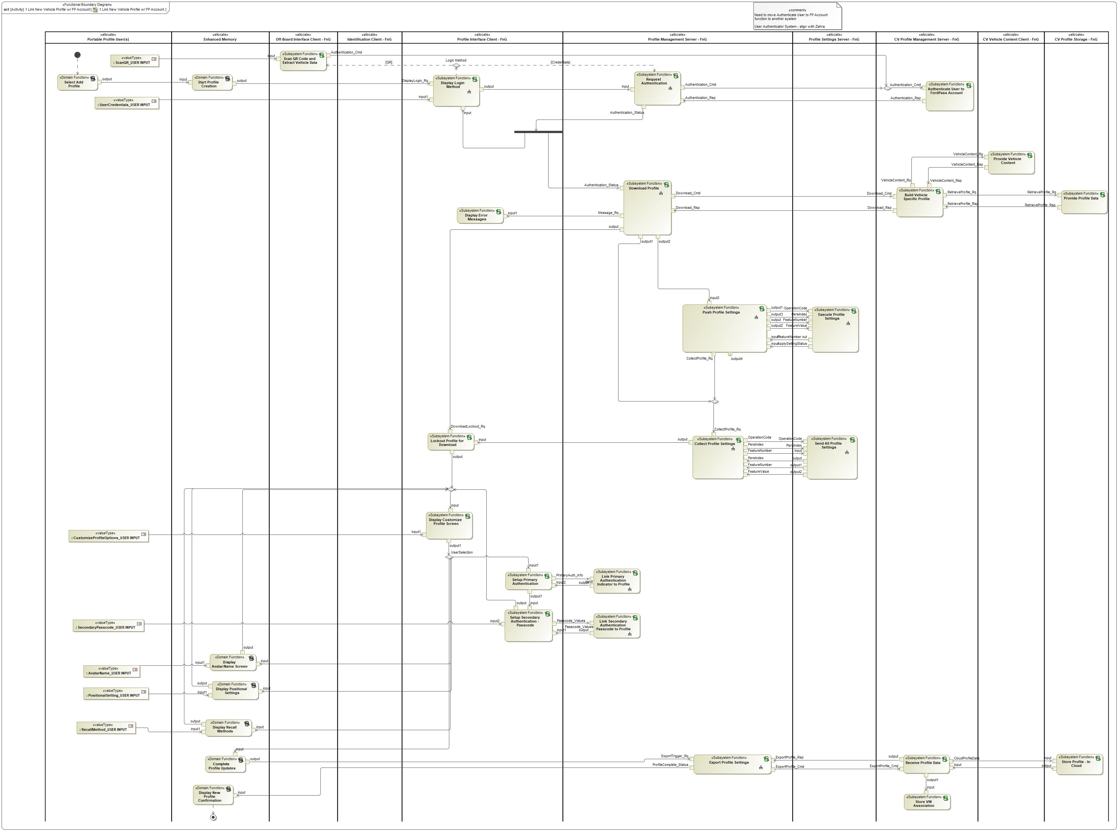

Figure : Activity Diagram of -2062184996.jpg “1 Link New Vehicle Profile w/ FP Account” calling -1749448761.jpg “Display Customize Profile Screen”

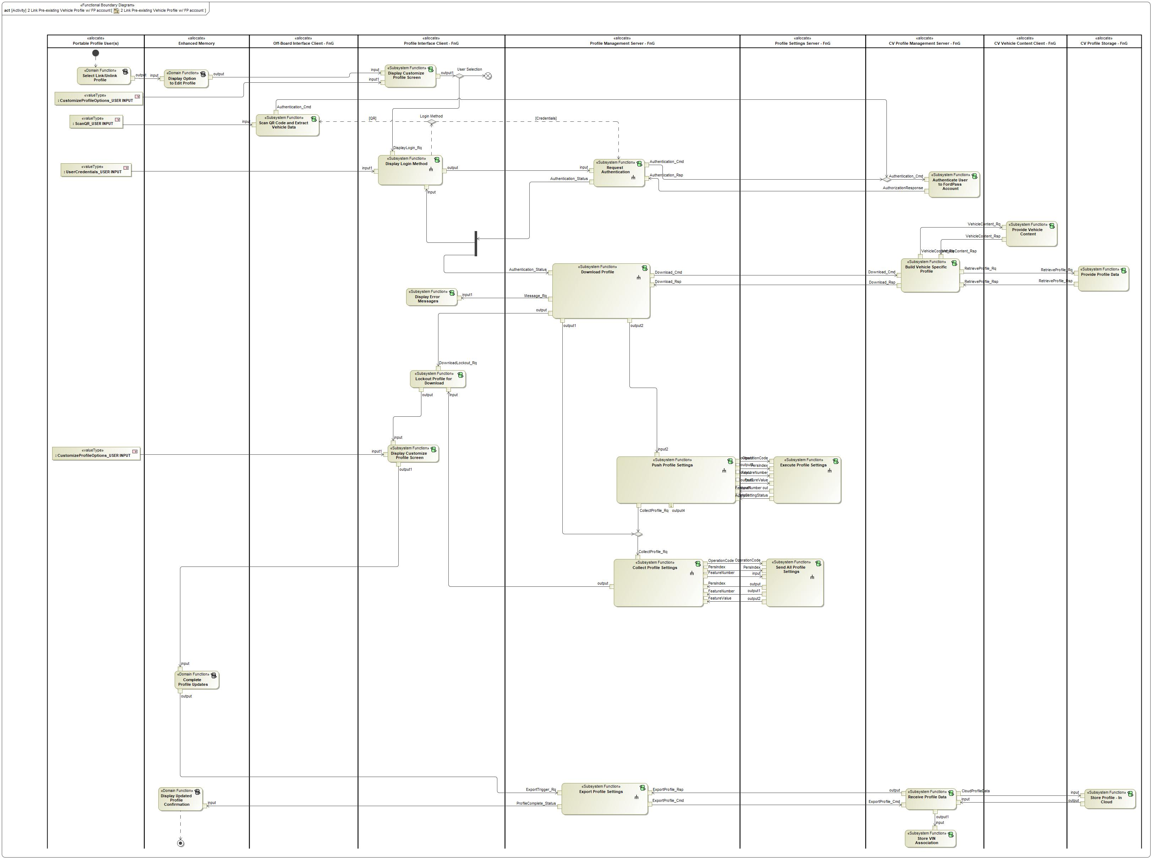

Figure : Activity Diagram of -2062184996.jpg “2 Link Pre-existing Vehicle Profile w/ FP account” calling -1749448761.jpg “Display Customize Profile Screen”

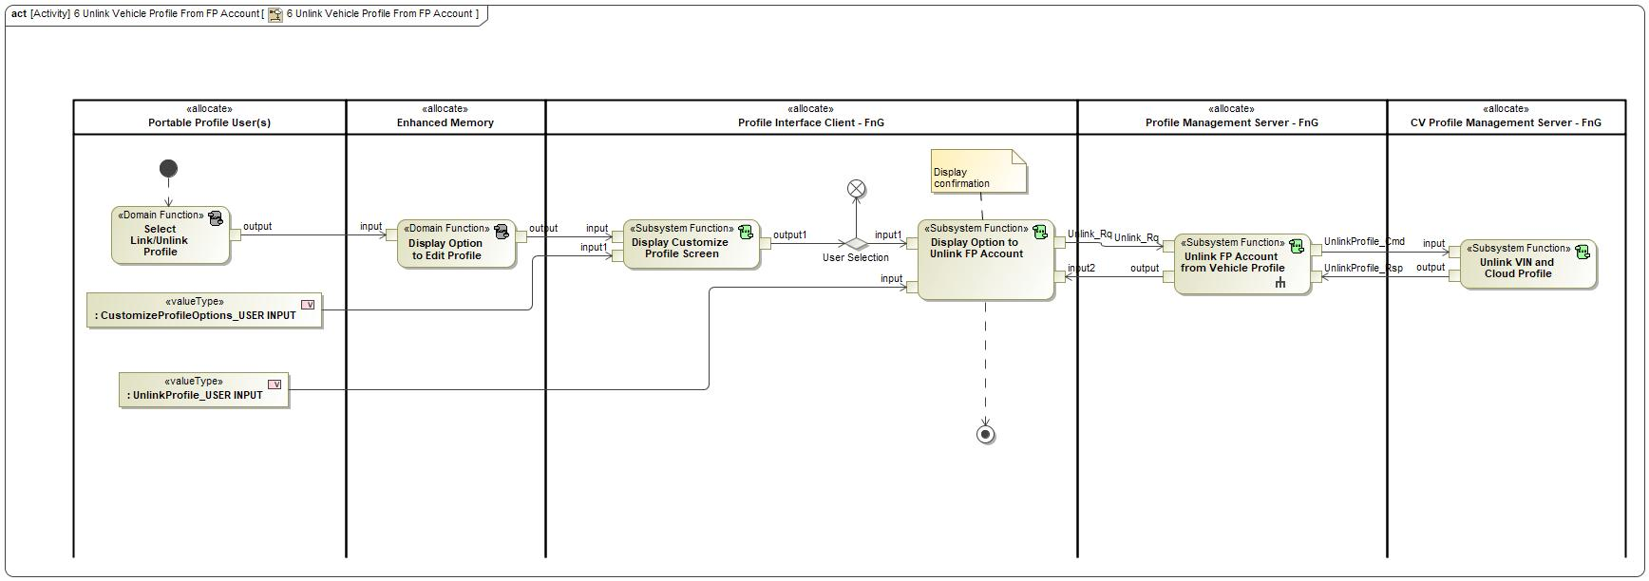

Figure : Activity Diagram of -2062184996.jpg “6 Unlink Vehicle Profile From FP Account” calling -1749448761.jpg “Display Customize Profile Screen”

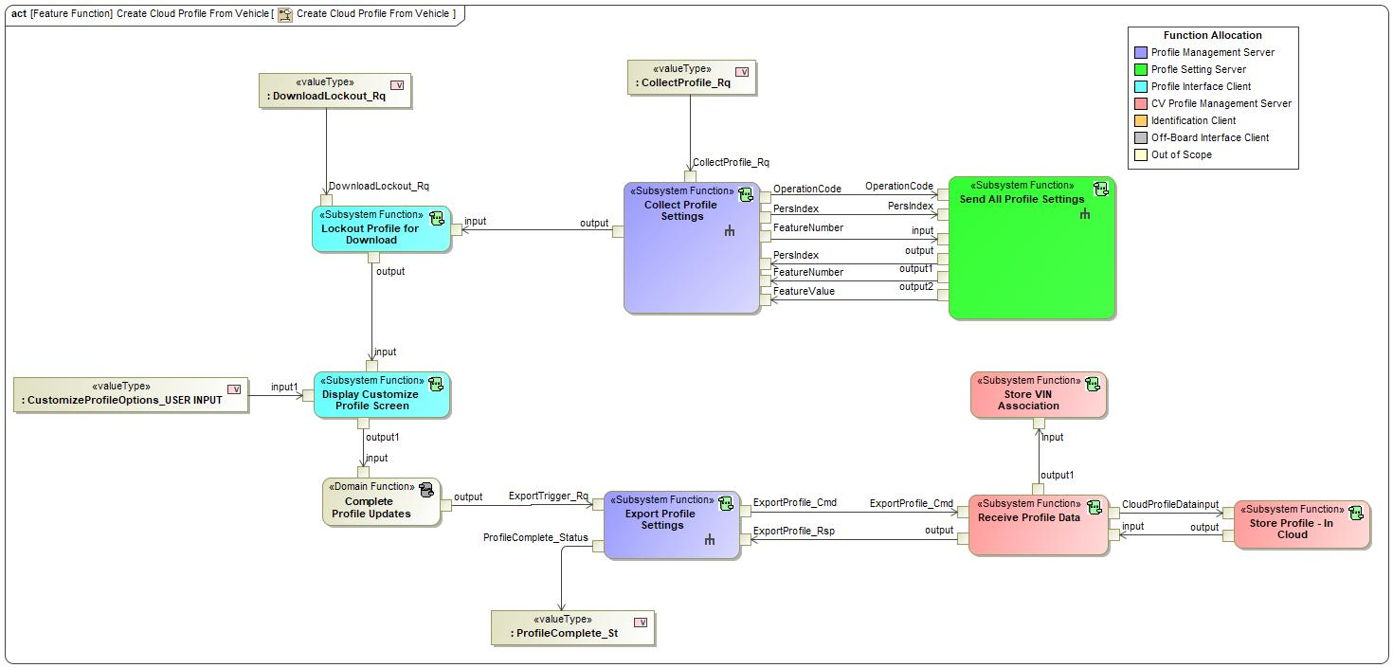

Figure : Activity Diagram of -1336703069.jpg “Create Cloud Profile From Vehicle” calling -1749448761.jpg “Display Customize Profile Screen”

### Function Interfaces

#### Logical Inputs

|  |  |
| --- | --- |
| **Signal Name** | **Description** |
| input1  Type:  91787509.jpg CustomizeProfileOptions_USER INPUT |  |
| input  Type:  91787509.jpg DisplayCustomizeScreen_Rq | Received from:   * -484950562.jpg Display Option to Edit Profile * -484950562.jpg Display Positional Settings * -1749448761.jpg Lockout Profile for Download * -484950562.jpg Display Recall Methods * -484950562.jpg Display Avatar/Name Screen * -1749448761.jpg Setup Secondary Authentication - Passcode |

#### Logical Outputs

|  |  |
| --- | --- |
| **Signal Name** | **Description** |
| output1  Type:  91787509.jpg CustomizeProfileSelection | Sent to:   * -1749448761.jpg Setup Primary Authentication * -484950562.jpg Complete Profile Updates * -484950562.jpg Display Positional Settings * -484950562.jpg Display Recall Methods * -1749448761.jpg Display Login Method * -484950562.jpg Display Avatar/Name Screen * -1749448761.jpg Display Option to Unlink FP Account |

#### Logical Parameters

*Not supported by MagicDraw report generation.*

### Function Modeling

#### Use Cases

*Not supported by MagicDraw report generation.*

#### State Charts / Activity Diagrams / Sequence Diagrams / Decision Tables

No diagrams internal to function specified.

### Function Requirements

#### Functional Requirements

##### Normal Operation

No Normal Operation Requirements specified.

##### Error Handling

No Error Handling Requirements specified.

#### Non-Functional Requirements

No Non-Functional Requirements specified.

#### Functional Safety Requirements

No Functional Safety Requirements specified.

##### ASIL Decomposition of Functional Safety Requirements

No Functional Safety Requirements with ASIL Decompositions specified.

#### Other Requirements

##### Design Requirements

No Design Requirements specified.

## -1785743972.jpg Display Error Messages

### Function Overview

#### Description

Function is allocated to:

* -1494991138.jpg Display Error Messages - APIM <<Logical>>
* -1143646936.jpg Profile Interface Client - FnG <<Logical>>

This function communicates error messages from other functions to the user.

#### Variants

*Not supported by MagicDraw report generation.*

#### Input Requirements

*Not supported by MagicDraw report generation.*

#### Assumptions

No assumptions specified for this function.

#### References

##### Ford Documents

List here all Ford internal documents, which are directly related to the feature.

| **Reference** | **Title** | **Doc. ID** | **Revision** |
| --- | --- | --- | --- |
|  |  |  |  |

Table 5: Ford internal Documents *(not specified in model)*

##### External Documents and Publications

The list of external documents could include books, reports and online sources.

| **Reference** | **Document / Publication** |
| --- | --- |
|  |  |

Table 7: External documents and publications *(not specified in model)*

#### Glossary

See Appendix for Definitions and Abbreviations.

### Function Scope

The -1785743972.jpg **– “Display Error Messages”** function is called by the following functions:

* -2062184996.jpg – “1 Link New Vehicle Profile w/ FP Account”
* -2062184996.jpg – “2 Link Pre-existing Vehicle Profile w/ FP account”
* -2062184996.jpg – “9 Recall Profile and ID User”
* 1456780828.jpg – “Synchronize Settings on Vehicle”



Figure : Activity Diagram of -2062184996.jpg “1 Link New Vehicle Profile w/ FP Account” calling -1785743972.jpg “Display Error Messages”



Figure : Activity Diagram of -2062184996.jpg “2 Link Pre-existing Vehicle Profile w/ FP account” calling -1785743972.jpg “Display Error Messages”



Figure : Activity Diagram of -2062184996.jpg “9 Recall Profile and ID User” calling -1785743972.jpg “Display Error Messages”

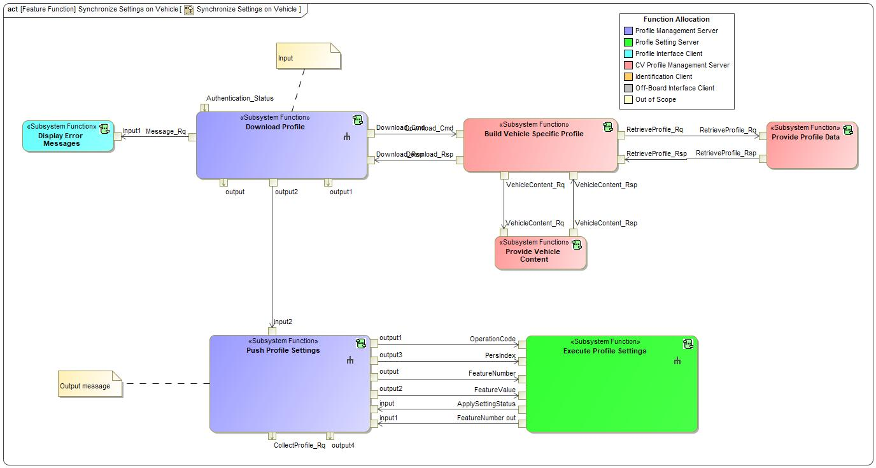

Figure : Activity Diagram of 1456780828.jpg “Synchronize Settings on Vehicle” calling -1785743972.jpg “Display Error Messages”

### Function Interfaces

#### Logical Inputs

|  |  |
| --- | --- |
| **Signal Name** | **Description** |
| input1  Type:  91787509.jpg Message_Rq | Signal Description:  Generic signal from Profile Management Server to Profile Interface Client to request a message to the user.  Received from:   * 596313585.jpg Download Profile |

#### Logical Outputs

No Logical Outputs specified.

#### Logical Parameters

*Not supported by MagicDraw report generation.*

### Function Modeling

#### Use Cases

*Not supported by MagicDraw report generation.*

#### State Charts / Activity Diagrams / Sequence Diagrams / Decision Tables

No diagrams internal to function specified.

### Function Requirements

#### Functional Requirements

##### Normal Operation

No Normal Operation Requirements specified.

##### Error Handling

No Error Handling Requirements specified.

#### Non-Functional Requirements

No Non-Functional Requirements specified.

#### Functional Safety Requirements

No Functional Safety Requirements specified.

##### ASIL Decomposition of Functional Safety Requirements

No Functional Safety Requirements with ASIL Decompositions specified.

#### Other Requirements

##### Design Requirements

No Design Requirements specified.

## -1749448761.jpg Display Login Method

### Function Overview

#### Description

Function is allocated to:

* -1494991138.jpg Display Login Method - APIM <<Logical>>
* -1143646936.jpg Profile Interface Client - FnG <<Logical>>

This is an HMI function that is displayed to collect user credentials from the user. The credentials are used to authenticate a user in order to link their profile to their FordPass account and import their profile settings.

#### Variants

*Not supported by MagicDraw report generation.*

#### Input Requirements

*Not supported by MagicDraw report generation.*

#### Assumptions

No assumptions specified for this function.

#### References

##### Ford Documents

List here all Ford internal documents, which are directly related to the feature.

| **Reference** | **Title** | **Doc. ID** | **Revision** |
| --- | --- | --- | --- |
|  |  |  |  |

Table 5: Ford internal Documents *(not specified in model)*

##### External Documents and Publications

The list of external documents could include books, reports and online sources.

| **Reference** | **Document / Publication** |
| --- | --- |
|  |  |

Table 7: External documents and publications *(not specified in model)*

#### Glossary

See Appendix for Definitions and Abbreviations.

### Function Scope

The -1749448761.jpg **– “Display Login Method”** function is called by the following functions:

* -2062184996.jpg – “1 Link New Vehicle Profile w/ FP Account”
* -2062184996.jpg – “2 Link Pre-existing Vehicle Profile w/ FP account”
* -1336703069.jpg – “Link FordPass Account with In-Vehicle Profile”



Figure : Activity Diagram of -2062184996.jpg “1 Link New Vehicle Profile w/ FP Account” calling -1749448761.jpg “Display Login Method”



Figure : Activity Diagram of -2062184996.jpg “2 Link Pre-existing Vehicle Profile w/ FP account” calling -1749448761.jpg “Display Login Method”



Figure : Activity Diagram of -1336703069.jpg “Link FordPass Account with In-Vehicle Profile” calling -1749448761.jpg “Display Login Method”

### Function Interfaces

#### Logical Inputs

|  |  |
| --- | --- |
| **Signal Name** | **Description** |
| input1  Type:  91787509.jpg UserCredentials_USER INPUT |  |
| input  Type:  1791080190.jpg Authentication_Status | Signal Description:  Internal vehicle status that broadcasts if a profile is authenticated or not.  Received from:   * -1749448761.jpg Request Authentication |
| DisplayLogin_Rq  Type:  91787509.jpg DisplayLogin_Rq | Received from:   * -484950562.jpg Start Profile Creation * -1749448761.jpg Display Customize Profile Screen |

#### Logical Outputs

|  |  |
| --- | --- |
| **Signal Name** | **Description** |
| output  Type:  91787509.jpg ProfileCredentials | Signal Description:  Credential values that are collected by Profile Interface Client and sent to the Profile Management Server.  Sent to:   * -1749448761.jpg Request Authentication |

#### Logical Parameters

*Not supported by MagicDraw report generation.*

### Function Modeling

#### Use Cases

*Not supported by MagicDraw report generation.*

#### State Charts / Activity Diagrams / Sequence Diagrams / Decision Tables

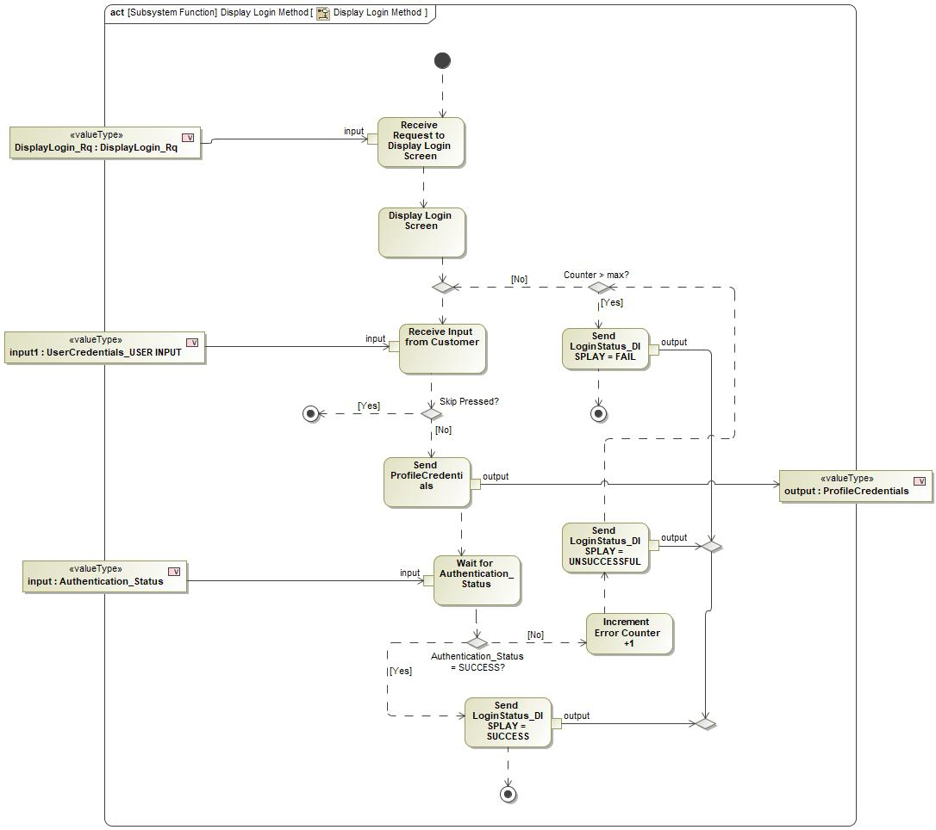

Figure : Display Login Method

### Function Requirements

#### Functional Requirements

##### Normal Operation

REQ-405766/A Login Method Options

When in-vehicle profile creation is started and the DisplayLogin_Rq is received, the Profile Interface Client shall provide one or a combination of the following login methods:

- Username and Password

- QR Code

|  |  |  |  |  |  |  |  |
| --- | --- | --- | --- | --- | --- | --- | --- |
| Requirement ID: REQ-405766/A | | | | | | | |
| **Rationale** |  | | | | | | |
| **Acceptance Criteria** |  | | | | | | |
| **Notes** |  | | | | | | |
| **Source** |  | | | | | **Owner** |  |
| **Source Req.** |  | | | | | **V&V Method** |  |
| **Type** |  | | | **Priority** |  | **Status** |  |
| [Req. Template](http://wiki.ford.com/display/RequirementsEngineering/Requirements+Attributes) Version | | 6.0 | End of Requirement | | | | |

REQ-405767/A Passing Credentials to Profile Management Server

When a user enters login credentials via the Profile Interface Client, the credentials shall be sent from the Profile Interface Client to the Profile Management Server via the ProfileCredential_Value signal.

|  |  |  |  |  |  |  |  |
| --- | --- | --- | --- | --- | --- | --- | --- |
| Requirement ID: REQ-405767/A | | | | | | | |
| **Rationale** |  | | | | | | |
| **Acceptance Criteria** |  | | | | | | |
| **Notes** |  | | | | | | |
| **Source** |  | | | | | **Owner** |  |
| **Source Req.** |  | | | | | **V&V Method** |  |
| **Type** |  | | | **Priority** |  | **Status** |  |
| [Req. Template](http://wiki.ford.com/display/RequirementsEngineering/Requirements+Attributes) Version | | 6.0 | End of Requirement | | | | |

REQ-405769/A Maximum login attempts reached

When the maximum (max = 5) attempts to login has been reached, the Profile Interface Client shall display an error message and return to the main profile screen.

|  |  |  |  |  |  |  |  |
| --- | --- | --- | --- | --- | --- | --- | --- |
| Requirement ID: REQ-405769/A | | | | | | | |
| **Rationale** |  | | | | | | |
| **Acceptance Criteria** |  | | | | | | |
| **Notes** |  | | | | | | |
| **Source** |  | | | | | **Owner** |  |
| **Source Req.** |  | | | | | **V&V Method** |  |
| **Type** |  | | | **Priority** |  | **Status** |  |
| [Req. Template](http://wiki.ford.com/display/RequirementsEngineering/Requirements+Attributes) Version | | 6.0 | End of Requirement | | | | |

##### Error Handling

REQ-405768/A Login Credential Failure

If the user credentials are not successfully authenticated, the Profile Interface Client shall allow the customer to re-enter their credentials, or use any other login method, up to 5 times.

|  |  |  |  |  |  |  |  |
| --- | --- | --- | --- | --- | --- | --- | --- |
| Requirement ID: REQ-405768/A | | | | | | | |
| **Rationale** |  | | | | | | |
| **Acceptance Criteria** |  | | | | | | |
| **Notes** |  | | | | | | |
| **Source** |  | | | | | **Owner** |  |
| **Source Req.** |  | | | | | **V&V Method** |  |
| **Type** |  | | | **Priority** |  | **Status** |  |
| [Req. Template](http://wiki.ford.com/display/RequirementsEngineering/Requirements+Attributes) Version | | 6.0 | End of Requirement | | | | |

#### Non-Functional Requirements

No Non-Functional Requirements specified.

#### Functional Safety Requirements

No Functional Safety Requirements specified.

##### ASIL Decomposition of Functional Safety Requirements

No Functional Safety Requirements with ASIL Decompositions specified.

#### Other Requirements

##### Design Requirements

No Design Requirements specified.

#### Uncategorized Requirements

DID to track method of login used

The Profile Interface Client shall create a DID that will track the method to login to the vehicle that is used by the user.

- one DID to track username/password entry as a login

- one DID to track QR code as a login

|  |  |  |  |  |  |  |  |
| --- | --- | --- | --- | --- | --- | --- | --- |
| Requirement ID: | | | | | | | |
| **Rationale** |  | | | | | | |
| **Acceptance Criteria** |  | | | | | | |
| **Notes** |  | | | | | | |
| **Source** |  | | | | | **Owner** |  |
| **Source Req.** |  | | | | | **V&V Method** |  |
| **Type** |  | | | **Priority** |  | **Status** |  |
| [Req. Template](http://wiki.ford.com/display/RequirementsEngineering/Requirements+Attributes) Version | | 6.0 | End of Requirement | | | | |

## -1749448761.jpg Display Option to Unlink FP Account

### Function Overview

#### Description

Function is allocated to:

* -1494991138.jpg Display Option to Unlink FP Account - APIM <<Logical>>
* -1143646936.jpg Profile Interface Client - FnG <<Logical>>

HMI function that provides the capability for the user to link their FP account to any pre-existing vehicle profiles.

#### Variants

*Not supported by MagicDraw report generation.*

#### Input Requirements

*Not supported by MagicDraw report generation.*

#### Assumptions

No assumptions specified for this function.

#### References

##### Ford Documents

List here all Ford internal documents, which are directly related to the feature.

| **Reference** | **Title** | **Doc. ID** | **Revision** |
| --- | --- | --- | --- |
|  |  |  |  |

Table 5: Ford internal Documents *(not specified in model)*

##### External Documents and Publications

The list of external documents could include books, reports and online sources.

| **Reference** | **Document / Publication** |
| --- | --- |
|  |  |

Table 7: External documents and publications *(not specified in model)*

#### Glossary

See Appendix for Definitions and Abbreviations.

### Function Scope

The -1749448761.jpg **– “Display Option to Unlink FP Account”** function is called by the following functions:

* -2062184996.jpg – “6 Unlink Vehicle Profile From FP Account”
* 1456780828.jpg – “Unlink FordPass Account with In-Vehicle Profile”



Figure : Activity Diagram of -2062184996.jpg “6 Unlink Vehicle Profile From FP Account” calling -1749448761.jpg “Display Option to Unlink FP Account”

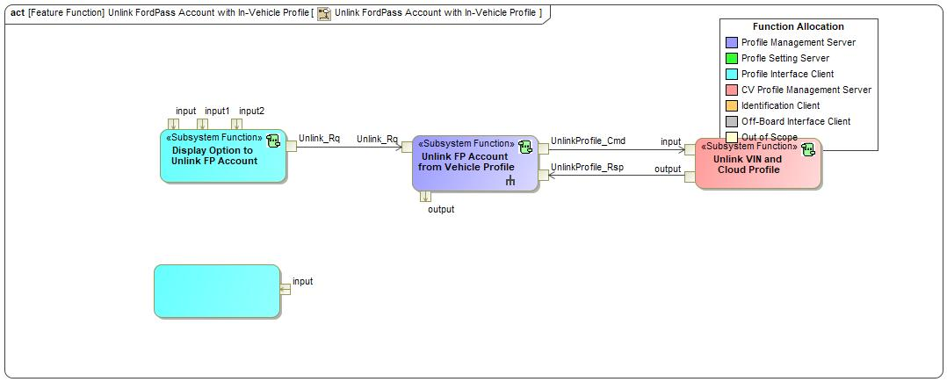

Figure : Activity Diagram of 1456780828.jpg “Unlink FordPass Account with In-Vehicle Profile” calling -1749448761.jpg “Display Option to Unlink FP Account”

### Function Interfaces

#### Logical Inputs

|  |  |
| --- | --- |
| **Signal Name** | **Description** |
| input1  Type:  91787509.jpg CustomizeProfileSelection | Received from:   * -1749448761.jpg Display Customize Profile Screen |
| input  Type:  91787509.jpg UnlinkProfile_USER INPUT |  |
| input2  Type:  91787509.jpg Unlink_Rsp | Signal Description:  Response to the Unlink_Rq indicating a Success or Fail.  Received from:   * 596313585.jpg Unlink FP Account from Vehicle Profile |

#### Logical Outputs

|  |  |
| --- | --- |
| **Signal Name** | **Description** |
| Unlink_Rq  Type:  91787509.jpg Unlink_Rq | Signal Description:  Request from the Profile Interface Client to the Profile Management Server to unlink a profile from its linked FordPass account.  Sent to:   * 596313585.jpg Unlink FP Account from Vehicle Profile |

#### Logical Parameters

*Not supported by MagicDraw report generation.*

### Function Modeling

#### Use Cases

*Not supported by MagicDraw report generation.*

#### State Charts / Activity Diagrams / Sequence Diagrams / Decision Tables

No diagrams internal to function specified.

### Function Requirements

#### Functional Requirements

##### Normal Operation

No Normal Operation Requirements specified.

##### Error Handling

No Error Handling Requirements specified.

#### Non-Functional Requirements

No Non-Functional Requirements specified.

#### Functional Safety Requirements

No Functional Safety Requirements specified.

##### ASIL Decomposition of Functional Safety Requirements

No Functional Safety Requirements with ASIL Decompositions specified.

#### Other Requirements

##### Design Requirements

No Design Requirements specified.

## -1749448761.jpg Display Secondary Passcode Screen

### Function Overview

#### Description

Function is allocated to:

* -1494991138.jpg Display Secondary Passcode Screen - APIM <<Logical>>
* -1143646936.jpg Profile Interface Client - FnG <<Logical>>

This function displays a screen that allows the user to enter their passcode.

#### Variants

*Not supported by MagicDraw report generation.*

#### Input Requirements

*Not supported by MagicDraw report generation.*

#### Assumptions

No assumptions specified for this function.

#### References

##### Ford Documents

List here all Ford internal documents, which are directly related to the feature.

| **Reference** | **Title** | **Doc. ID** | **Revision** |
| --- | --- | --- | --- |
|  |  |  |  |

Table 5: Ford internal Documents *(not specified in model)*

##### External Documents and Publications

The list of external documents could include books, reports and online sources.

| **Reference** | **Document / Publication** |
| --- | --- |
|  |  |

Table 7: External documents and publications *(not specified in model)*

#### Glossary

See Appendix for Definitions and Abbreviations.

### Function Scope

The -1749448761.jpg **– “Display Secondary Passcode Screen”** function is called by the following functions:

* -2062184996.jpg – “9 Recall Profile and ID User”



Figure : Activity Diagram of -2062184996.jpg “9 Recall Profile and ID User” calling -1749448761.jpg “Display Secondary Passcode Screen”

### Function Interfaces

#### Logical Inputs

|  |  |
| --- | --- |
| **Signal Name** | **Description** |
| input1  Type:  91787509.jpg SecondaryPasscode_USER INPUT |  |
| input  Type:  91787509.jpg Passcode_Rq | Signal Description:  Signal from Profile Management Server to Profile Interface Client to display the passcode screen.  Received from:   * -1749448761.jpg Provide Authentication Status (Auto Login) |

#### Logical Outputs

|  |  |
| --- | --- |
| **Signal Name** | **Description** |
| output  Type:  91787509.jpg PasscodeValues | Signal Description:  Passcode values received by the user and passed to Profile Management Server.  Sent to:   * -1749448761.jpg Provide Authentication Status (Auto Login) |

#### Logical Parameters

*Not supported by MagicDraw report generation.*

### Function Modeling

#### Use Cases

*Not supported by MagicDraw report generation.*

#### State Charts / Activity Diagrams / Sequence Diagrams / Decision Tables

No diagrams internal to function specified.

### Function Requirements

#### Functional Requirements

##### Normal Operation

No Normal Operation Requirements specified.

##### Error Handling

No Error Handling Requirements specified.

#### Non-Functional Requirements

No Non-Functional Requirements specified.

#### Functional Safety Requirements

No Functional Safety Requirements specified.

##### ASIL Decomposition of Functional Safety Requirements

No Functional Safety Requirements with ASIL Decompositions specified.

#### Other Requirements

##### Design Requirements

No Design Requirements specified.

## -1749448761.jpg Display Welcome Screen with ID Method

### Function Overview

#### Description

Function is allocated to:

* -1494991138.jpg Display Welcome Screen with ID Method - APIM <<Logical>>
* -1143646936.jpg Profile Interface Client - FnG <<Logical>>

This function is used during the Remote Vehicle Setup (RVS) scenario and is allocated to the Profile Interface Client. This function displays a welcome screen to the customer and provides a method for the customer to provide positive ID.

#### Variants

*Not supported by MagicDraw report generation.*

#### Input Requirements

*Not supported by MagicDraw report generation.*

#### Assumptions

No assumptions specified for this function.

#### References

##### Ford Documents

List here all Ford internal documents, which are directly related to the feature.

| **Reference** | **Title** | **Doc. ID** | **Revision** |
| --- | --- | --- | --- |
|  |  |  |  |

Table 5: Ford internal Documents *(not specified in model)*

##### External Documents and Publications

The list of external documents could include books, reports and online sources.

| **Reference** | **Document / Publication** |
| --- | --- |
|  |  |

Table 7: External documents and publications *(not specified in model)*

#### Glossary

See Appendix for Definitions and Abbreviations.

### Function Scope

The -1749448761.jpg **– “Display Welcome Screen with ID Method”** function is called by the following functions:

* -2062184996.jpg – “14 Send Profile to vehicle from Off-Board Interface”

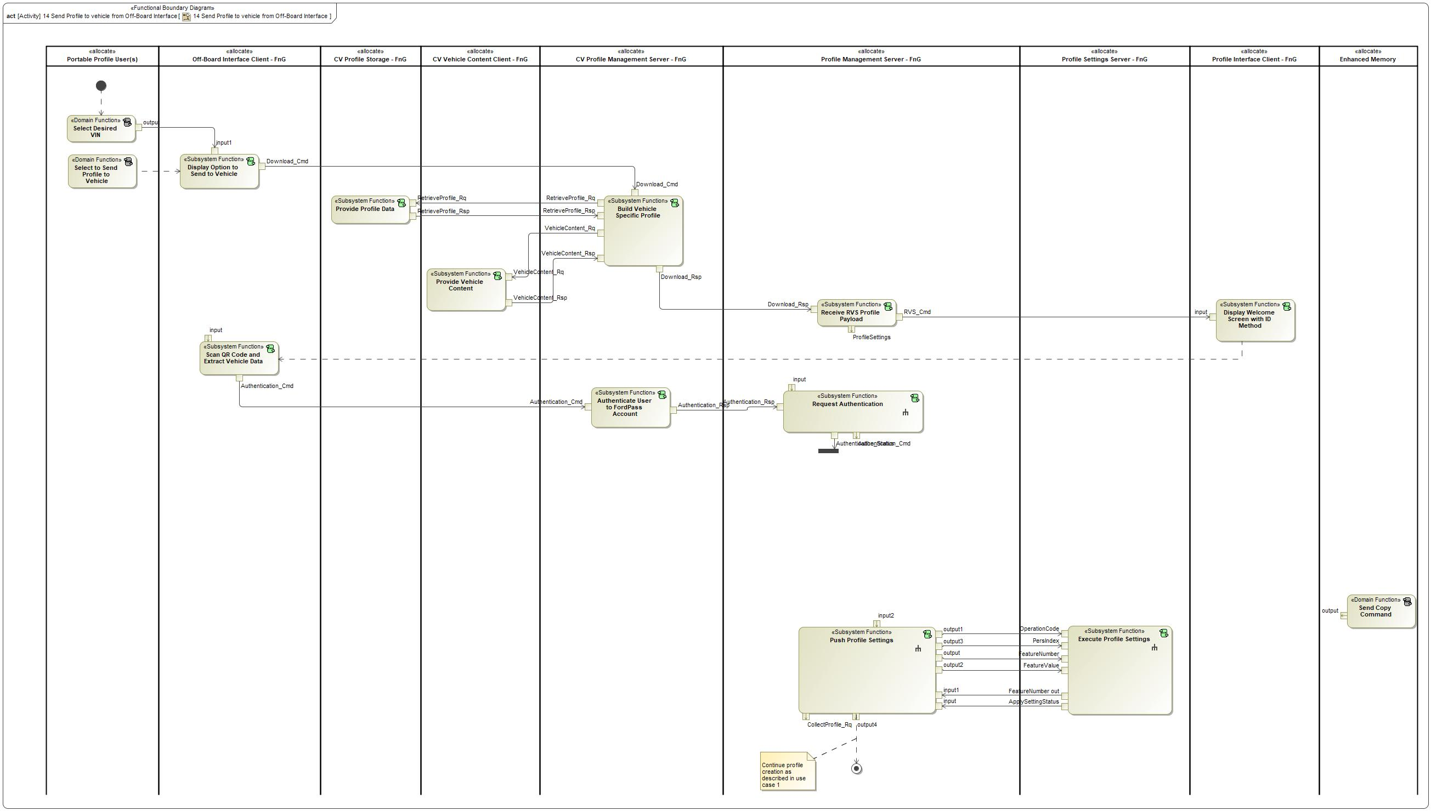

Figure : Activity Diagram of -2062184996.jpg “14 Send Profile to vehicle from Off-Board Interface” calling -1749448761.jpg “Display Welcome Screen with ID Method”

### Function Interfaces

#### Logical Inputs

|  |  |
| --- | --- |
| **Signal Name** | **Description** |
| input  Type:  91787509.jpg RVS_Cmd | Signal Description:  A command from Profile Management Server to Profile Interface Client to indicate a RVS payload has been received by the vehicle.  Received from:   * 596313585.jpg Receive RVS Profile Payload |

#### Logical Outputs

No Logical Outputs specified.

#### Logical Parameters

*Not supported by MagicDraw report generation.*

### Function Modeling

#### Use Cases

*Not supported by MagicDraw report generation.*

#### State Charts / Activity Diagrams / Sequence Diagrams / Decision Tables

No diagrams internal to function specified.

### Function Requirements

#### Functional Requirements

##### Normal Operation

No Normal Operation Requirements specified.

##### Error Handling

No Error Handling Requirements specified.

#### Non-Functional Requirements

No Non-Functional Requirements specified.

#### Functional Safety Requirements

No Functional Safety Requirements specified.

##### ASIL Decomposition of Functional Safety Requirements

No Functional Safety Requirements with ASIL Decompositions specified.

#### Other Requirements

##### Design Requirements

No Design Requirements specified.

## -1749448761.jpg Lockout Profile for Download

### Function Overview

#### Description

Function is allocated to:

* -1494991138.jpg Lockout Profile for Download - APIM <<Logical>>
* -1143646936.jpg Profile Interface Client - FnG <<Logical>>

This function is allocated to the Profile Interface Client and provides an HMI graphic that locks out the HMI screen so that the customer cannot make any changes while the PPP feature is applying settings.

#### Variants

*Not supported by MagicDraw report generation.*

#### Input Requirements

*Not supported by MagicDraw report generation.*

#### Assumptions

No assumptions specified for this function.

#### References

##### Ford Documents

List here all Ford internal documents, which are directly related to the feature.

| **Reference** | **Title** | **Doc. ID** | **Revision** |
| --- | --- | --- | --- |
|  |  |  |  |

Table 5: Ford internal Documents *(not specified in model)*

##### External Documents and Publications

The list of external documents could include books, reports and online sources.

| **Reference** | **Document / Publication** |
| --- | --- |
|  |  |

Table 7: External documents and publications *(not specified in model)*

#### Glossary

See Appendix for Definitions and Abbreviations.

### Function Scope

The -1749448761.jpg **– “Lockout Profile for Download”** function is called by the following functions:

* -2062184996.jpg – “1 Link New Vehicle Profile w/ FP Account”
* -2062184996.jpg – “2 Link Pre-existing Vehicle Profile w/ FP account”
* -1336703069.jpg – “Create Cloud Profile From Vehicle”



Figure : Activity Diagram of -2062184996.jpg “1 Link New Vehicle Profile w/ FP Account” calling -1749448761.jpg “Lockout Profile for Download”



Figure : Activity Diagram of -2062184996.jpg “2 Link Pre-existing Vehicle Profile w/ FP account” calling -1749448761.jpg “Lockout Profile for Download”



Figure : Activity Diagram of -1336703069.jpg “Create Cloud Profile From Vehicle” calling -1749448761.jpg “Lockout Profile for Download”

### Function Interfaces

#### Logical Inputs

|  |  |
| --- | --- |
| **Signal Name** | **Description** |
| DownloadLockout_Rq  Type:  91787509.jpg DownloadLockout_Rq | Signal Description:  A command sent to the Profile Interface Client when the Profile Management Server is actively applying profile data.  Received from:   * 596313585.jpg Download Profile |
| input  Type:  91787509.jpg DownloadComplete | Signal Description:  Signal to indicate to the Profile Interface Client that the profile download/creation is complete and the screen no longer needs to be locked out.  Received from:   * 596313585.jpg Collect Profile Settings |

#### Logical Outputs

|  |  |
| --- | --- |
| **Signal Name** | **Description** |
| output  Type:  91787509.jpg DisplayCustomizeScreen_Rq | Sent to:   * -1749448761.jpg Display Customize Profile Screen |

#### Logical Parameters

*Not supported by MagicDraw report generation.*

### Function Modeling

#### Use Cases

*Not supported by MagicDraw report generation.*

#### State Charts / Activity Diagrams / Sequence Diagrams / Decision Tables

No diagrams internal to function specified.

### Function Requirements

#### Functional Requirements

##### Normal Operation

No Normal Operation Requirements specified.

##### Error Handling

No Error Handling Requirements specified.

#### Non-Functional Requirements

No Non-Functional Requirements specified.

#### Functional Safety Requirements

No Functional Safety Requirements specified.

##### ASIL Decomposition of Functional Safety Requirements

No Functional Safety Requirements with ASIL Decompositions specified.

#### Other Requirements

##### Design Requirements

No Design Requirements specified.

## -1749448761.jpg Setup Primary Authentication

### Function Overview

#### Description

Function is allocated to:

* -1143646936.jpg Profile Interface Client - FnG <<Logical>>
* -1494991138.jpg Setup Primary Authentication - APIM <<Logical>>

This is an HMI function that allows the user to setup their primary authentication method for their profile.

#### Variants

*Not supported by MagicDraw report generation.*

#### Input Requirements

*Not supported by MagicDraw report generation.*

#### Assumptions

No assumptions specified for this function.

#### References

##### Ford Documents

List here all Ford internal documents, which are directly related to the feature.

| **Reference** | **Title** | **Doc. ID** | **Revision** |
| --- | --- | --- | --- |
|  |  |  |  |

Table 5: Ford internal Documents *(not specified in model)*

##### External Documents and Publications

The list of external documents could include books, reports and online sources.

| **Reference** | **Document / Publication** |
| --- | --- |
|  |  |

Table 7: External documents and publications *(not specified in model)*

#### Glossary

See Appendix for Definitions and Abbreviations.

### Function Scope

The -1749448761.jpg **– “Setup Primary Authentication”** function is called by the following functions:

* -2062184996.jpg – “1 Link New Vehicle Profile w/ FP Account”



Figure : Activity Diagram of -2062184996.jpg “1 Link New Vehicle Profile w/ FP Account” calling -1749448761.jpg “Setup Primary Authentication”

### Function Interfaces

#### Logical Inputs

|  |  |
| --- | --- |
| **Signal Name** | **Description** |
| input1  Type:  91787509.jpg CustomizeProfileSelection | Received from:   * -1749448761.jpg Display Customize Profile Screen |
| input2  Type:  91787509.jpg PrimaryAuth_Rsp | Signal Description:  Signal from Profile Management Server to Profile Interface Client providing the status of the Primary Authentication linking to the active profile.  Received from:   * 596313585.jpg Link Primary Authentication Indicator to Profile |

#### Logical Outputs

|  |  |
| --- | --- |
| **Signal Name** | **Description** |
| PrimaryAuth_Info  Type:  91787509.jpg PrimaryAuth_Rq | Signal Description:  Signal from Profile Interface Client to Profile Management Server to store Primary Authentication for the active user.  Sent to:   * 596313585.jpg Link Primary Authentication Indicator to Profile |
| output1  Type:  91787509.jpg PrimaryAuthenticationSetupComplete | Sent to:   * -1749448761.jpg Setup Secondary Authentication - Passcode |

#### Logical Parameters

*Not supported by MagicDraw report generation.*

### Function Modeling

#### Use Cases

*Not supported by MagicDraw report generation.*

#### State Charts / Activity Diagrams / Sequence Diagrams / Decision Tables

No diagrams internal to function specified.

### Function Requirements

#### Functional Requirements

##### Normal Operation

No Normal Operation Requirements specified.

##### Error Handling

No Error Handling Requirements specified.

#### Non-Functional Requirements

No Non-Functional Requirements specified.

#### Functional Safety Requirements

No Functional Safety Requirements specified.

##### ASIL Decomposition of Functional Safety Requirements

No Functional Safety Requirements with ASIL Decompositions specified.

#### Other Requirements

##### Design Requirements

No Design Requirements specified.

## -1749448761.jpg Setup Secondary Authentication - Passcode

### Function Overview

#### Description

Function is allocated to:

* -1143646936.jpg Profile Interface Client - FnG <<Logical>>
* -1494991138.jpg Setup Secondary Authentication Passcode - APIM <<Logical>>

This is an HMI function that receives the secondary authentication passcode from the user. This function is executed when primary authentication of a user is unavailable or fails.

#### Variants

*Not supported by MagicDraw report generation.*

#### Input Requirements

*Not supported by MagicDraw report generation.*

#### Assumptions

No assumptions specified for this function.

#### References

##### Ford Documents

List here all Ford internal documents, which are directly related to the feature.

| **Reference** | **Title** | **Doc. ID** | **Revision** |
| --- | --- | --- | --- |
|  |  |  |  |

Table 5: Ford internal Documents *(not specified in model)*

##### External Documents and Publications

The list of external documents could include books, reports and online sources.

| **Reference** | **Document / Publication** |
| --- | --- |
|  |  |

Table 7: External documents and publications *(not specified in model)*

#### Glossary

See Appendix for Definitions and Abbreviations.

### Function Scope

The -1749448761.jpg **– “Setup Secondary Authentication - Passcode”** function is called by the following functions:

* -2062184996.jpg – “1 Link New Vehicle Profile w/ FP Account”
* -1336703069.jpg – “Identify Profile Owner”



Figure : Activity Diagram of -2062184996.jpg “1 Link New Vehicle Profile w/ FP Account” calling -1749448761.jpg “Setup Secondary Authentication - Passcode”



Figure : Activity Diagram of -1336703069.jpg “Identify Profile Owner” calling -1749448761.jpg “Setup Secondary Authentication - Passcode”

### Function Interfaces

#### Logical Inputs

|  |  |
| --- | --- |
| **Signal Name** | **Description** |
| input  Type:  91787509.jpg PrimaryAuthenticationSetupComplete | Received from:   * -1749448761.jpg Setup Primary Authentication |
| input1  Type:  91787509.jpg SetupSecondaryAuth_Rsp | Signal Description:  Response to creating the passcode.  Received from:   * 596313585.jpg Link Secondary Authentication Passcode to Profile |
| input2  Type:  91787509.jpg SecondaryPasscode_USER INPUT |  |

#### Logical Outputs

|  |  |
| --- | --- |
| **Signal Name** | **Description** |
| Passcode_Values  Type:  91787509.jpg SetupSecondaryAuth_Rq | Signal Description:  Passcode values sent from Profile Interface Client to Profile Management Server during initial passcode creation.  Sent to:   * 596313585.jpg Link Secondary Authentication Passcode to Profile * -1749448761.jpg Provide Authentication Status (Auto Login) |
| output  Type:  91787509.jpg DisplayCustomizeScreen_Rq | Sent to:   * -1749448761.jpg Display Customize Profile Screen |

#### Logical Parameters

*Not supported by MagicDraw report generation.*

### Function Modeling

#### Use Cases

*Not supported by MagicDraw report generation.*

#### State Charts / Activity Diagrams / Sequence Diagrams / Decision Tables

No diagrams internal to function specified.

### Function Requirements

#### Functional Requirements

##### Normal Operation

No Normal Operation Requirements specified.

##### Error Handling

No Error Handling Requirements specified.

#### Non-Functional Requirements

No Non-Functional Requirements specified.

#### Functional Safety Requirements

No Functional Safety Requirements specified.

##### ASIL Decomposition of Functional Safety Requirements

No Functional Safety Requirements with ASIL Decompositions specified.

#### Other Requirements

##### Design Requirements

No Design Requirements specified.

# Open Concerns

**#Hint:** The following list presents open concerns, which have to be discussed or clarified over the course of the on-going requirements engineering.

| ID | Concern Description | e-Tracker / Reference | Responsible | Status | Solution |
| --- | --- | --- | --- | --- | --- |
| 1 |  |  |  |  |  |

Table 8: Open Concerns *(Not supported by MagicDraw report generation.)*

# Revision History

**#Hint:** A new version number is assigned to a document with a given revision each time it is checked in to Team Center (TCSE). After release of a revision, the document cannot be edited and no new versions can be created on that revision. When updating the document after that, a new revision has to be created and new versions on that revision will be created upon checking in.

No Revision History found.

## Template Revisions

*#Important: Do not change this section*

|  |  |  |  |  |
| --- | --- | --- | --- | --- |
| Version | Rev. | Date | Description | Responsible |
| *1* | *0* | *2016-02-26* | *Initial version, derived from FDS* | *Jbaden1* |
| *1* | *1* | *2016-02-26* | *Word properties corrected* | *Jbaden1* |
| *1* | *2* | *2016-03-10* | *Clean up of document meta data (Word properties)* | *Jbaden1* |
| *1* | *3* | *2016-03-22* | * *Footer formatting corrected (Issue 19)* * *“Constraints” chapter renamed to “Input Requirements” (Issue 20)* | *Jbaden1* |
| *1* | *4* | *2016-04-20* | * *Broken Wiki links repaired* | *Jbaden1* |
| *2* | *0* | *2016-06-10* | * *Document metadata adapted. Prepared for new macros* * *DTC table removed* * *HMI function added as a chapter (details still to be refined)* * *Signal / Parameter IDs column deleted interface tables* | *Jbaden1* |
| *2* | *1* | *2016-07-14* | * *Converted to SysML diagrams* * *HMI section further elaborated* * *Template version added to footer* * *Dedicated Startup / Shutdown sections removed (only hints added)* * *Data Dictionary reworked and Signal / Parameter IDs column re-introduced* | *Jbaden1* |
| *2* | *2* | *2016-12-07* | * *Minor formatting changes* | *Jbaden1* |
| *3* |  |  | *Skipped to synchronize with Specification_Macros.dotm* |  |
| *4* |  |
| *5* | *0* | *2017-01-13* | * *Meta data updated for specification macros, version 3.1* * *SW Unit chapter removed for the time being* * *Green boxes added for user hints* | *Jbaden1* |
| *5* | *1* | *2017-01-18* | * *Some additional hints.* * *Hyperlinks highlighted in hints* | *Jbaden1* |
| *6* | *0* | *2017-04-28* | * *Editorial change. Hints added to chapter 4.1.4* * *Chapter “Traceability Matrix” removed* | *Jbaden1* |
| *6* | *0* | *2018-04-28* | * *CR69/63: New chapters added for Functional Safety (FTTI and Technical Safety Requirements)* * *CR53: New coversheet + additional meta-data* * *CR76: merge sections for configuration and for calibration parameters into one on Function Level* | *Jbaden1* |
| *6* | *0* | *2018-08-06* | * *CR66: Fix version numbering in footer of Function Spec* | *Jbaden1* |
| *6* | *0* | *2018-09-28* | * *Broken links to RE Wiki repaired* | *Jbaden1* |
| *6* | *0* | *2018-10-31* | * *Minor corrections on cover sheet and in footer to be more GIS compliant and VSEM aligned* * *“Overview” and “Description” exchanged in headings (following common sense)* | *Jbaden1* |
| *6* | *0* | *2018-11-12* | * *Explanatory text in Variants” section revised* * *Functional Safety modifications as agreed with FuSa core team (Baseline: November 2018 Dearborn On-Site)* | *Jbaden1* |
| *M* |  | *2019-04-02* | * *Initial version of SysML report template* | *snuesch* |
| *M* |  | *2019-04-05* | * *Improved dialog boxes to select function group* | *snuesch* |
| *M* |  | *2019-04-26* | * *Improved function interfaces (support of additional elements (e.g., send signal action, add structural feature action, merge node, decision node, activity parameter nodes, etc.) and pins)* | *snuesch* |
| *N* |  | *2019-08-19* | * *For each function now also requirements satisfied by activity parameter nodes and function outputs are populated.* | *snuesch* |
| *N* |  | *2019-08-21* | * *Improved glossary and acronym tables* | *snuesch* |
| *N* |  | *2019-09-20* | * *Updated Function Interfaces tables with better wording. Added a report template variable that allows to disable senders and receivers. Sorted requirements by ID.* | *snuesch* |
| *N* |  | *2019-09-27* | * *Green hints now only show up for first function.* * *labelTag variable can be used to filter revision history.* | *snuesch* |

# Appendix

## Data Dictionary

### Logical Signals

**#Macro:** [Add Ins -> Add Requirement macro](http://wiki.ford.com/display/RequirementsEngineering/Adding+a+Logical+Signal+or+Parameter) (select “Logical Signal” as type)

Authentication_Status

Internal vehicle status that broadcasts if a profile is authenticated or not.

|  |  |  |
| --- | --- | --- |
| **ASIL** | |  |
| **Encoding Type Name** | |  |
| Note: An encoding is either discrete or continuous. Delete fields below which are not needed | | |
| **Value**  (Continuous Encoding) | Min Value |  |
| Max Value |  |
| Resolution |  |
| Offset |  |
| **Value**  (Discrete  Encoding) |  |  |
| **Unit** | |  |

CustomizeProfileOptions_USER INPUT

|  |  |  |
| --- | --- | --- |
| **ASIL** | |  |
| **Encoding Type Name** | |  |
| Note: An encoding is either discrete or continuous. Delete fields below which are not needed | | |
| **Value**  (Continuous Encoding) | Min Value |  |
| Max Value |  |
| Resolution |  |
| Offset |  |
| **Value**  (Discrete  Encoding) |  |  |
| **Unit** | |  |

CustomizeProfileSelection

|  |  |  |
| --- | --- | --- |
| **ASIL** | |  |
| **Encoding Type Name** | |  |
| Note: An encoding is either discrete or continuous. Delete fields below which are not needed | | |
| **Value**  (Continuous Encoding) | Min Value |  |
| Max Value |  |
| Resolution |  |
| Offset |  |
| **Value**  (Discrete  Encoding) |  |  |
| **Unit** | |  |

DisplayCustomizeScreen_Rq

|  |  |  |
| --- | --- | --- |
| **ASIL** | |  |
| **Encoding Type Name** | |  |
| Note: An encoding is either discrete or continuous. Delete fields below which are not needed | | |
| **Value**  (Continuous Encoding) | Min Value |  |
| Max Value |  |
| Resolution |  |
| Offset |  |
| **Value**  (Discrete  Encoding) |  |  |
| **Unit** | |  |

DisplayLogin_Rq

|  |  |  |
| --- | --- | --- |
| **ASIL** | |  |
| **Encoding Type Name** | |  |
| Note: An encoding is either discrete or continuous. Delete fields below which are not needed | | |
| **Value**  (Continuous Encoding) | Min Value |  |
| Max Value |  |
| Resolution |  |
| Offset |  |
| **Value**  (Discrete  Encoding) |  |  |
| **Unit** | |  |

DownloadComplete

Signal to indicate to the Profile Interface Client that the profile download/creation is complete and the screen no longer needs to be locked out.

|  |  |  |
| --- | --- | --- |
| **ASIL** | |  |
| **Encoding Type Name** | |  |
| Note: An encoding is either discrete or continuous. Delete fields below which are not needed | | |
| **Value**  (Continuous Encoding) | Min Value |  |
| Max Value |  |
| Resolution |  |
| Offset |  |
| **Value**  (Discrete  Encoding) |  |  |
| **Unit** | |  |

DownloadLockout_Rq

A command sent to the Profile Interface Client when the Profile Management Server is actively applying profile data.

|  |  |  |
| --- | --- | --- |
| **ASIL** | |  |
| **Encoding Type Name** | |  |
| Note: An encoding is either discrete or continuous. Delete fields below which are not needed | | |
| **Value**  (Continuous Encoding) | Min Value |  |
| Max Value |  |
| Resolution |  |
| Offset |  |
| **Value**  (Discrete  Encoding) |  |  |
| **Unit** | |  |

Message_Rq

Generic signal from Profile Management Server to Profile Interface Client to request a message to the user.

|  |  |  |
| --- | --- | --- |
| **ASIL** | |  |
| **Encoding Type Name** | |  |
| Note: An encoding is either discrete or continuous. Delete fields below which are not needed | | |
| **Value**  (Continuous Encoding) | Min Value |  |
| Max Value |  |
| Resolution |  |
| Offset |  |
| **Value**  (Discrete  Encoding) |  |  |
| **Unit** | |  |

PasscodeValues

Passcode values received by the user and passed to Profile Management Server.

|  |  |  |
| --- | --- | --- |
| **ASIL** | |  |
| **Encoding Type Name** | |  |
| Note: An encoding is either discrete or continuous. Delete fields below which are not needed | | |
| **Value**  (Continuous Encoding) | Min Value |  |
| Max Value |  |
| Resolution |  |
| Offset |  |
| **Value**  (Discrete  Encoding) |  |  |
| **Unit** | |  |

Passcode_Rq

Signal from Profile Management Server to Profile Interface Client to display the passcode screen.

|  |  |  |
| --- | --- | --- |
| **ASIL** | |  |
| **Encoding Type Name** | |  |
| Note: An encoding is either discrete or continuous. Delete fields below which are not needed | | |
| **Value**  (Continuous Encoding) | Min Value |  |
| Max Value |  |
| Resolution |  |
| Offset |  |
| **Value**  (Discrete  Encoding) |  |  |
| **Unit** | |  |

PrimaryAuthenticationSetupComplete

|  |  |  |
| --- | --- | --- |
| **ASIL** | |  |
| **Encoding Type Name** | |  |
| Note: An encoding is either discrete or continuous. Delete fields below which are not needed | | |
| **Value**  (Continuous Encoding) | Min Value |  |
| Max Value |  |
| Resolution |  |
| Offset |  |
| **Value**  (Discrete  Encoding) |  |  |
| **Unit** | |  |

PrimaryAuth_Rq

Signal from Profile Interface Client to Profile Management Server to store Primary Authentication for the active user.

|  |  |  |
| --- | --- | --- |
| **ASIL** | |  |
| **Encoding Type Name** | |  |
| Note: An encoding is either discrete or continuous. Delete fields below which are not needed | | |
| **Value**  (Continuous Encoding) | Min Value |  |
| Max Value |  |
| Resolution |  |
| Offset |  |
| **Value**  (Discrete  Encoding) |  |  |
| **Unit** | |  |

PrimaryAuth_Rsp

Signal from Profile Management Server to Profile Interface Client providing the status of the Primary Authentication linking to the active profile.

|  |  |  |
| --- | --- | --- |
| **ASIL** | |  |
| **Encoding Type Name** | |  |
| Note: An encoding is either discrete or continuous. Delete fields below which are not needed | | |
| **Value**  (Continuous Encoding) | Min Value |  |
| Max Value |  |
| Resolution |  |
| Offset |  |
| **Value**  (Discrete  Encoding) |  |  |
| **Unit** | |  |

ProfileCredentials

Credential values that are collected by Profile Interface Client and sent to the Profile Management Server.

|  |  |  |
| --- | --- | --- |
| **ASIL** | |  |
| **Encoding Type Name** | |  |
| Note: An encoding is either discrete or continuous. Delete fields below which are not needed | | |
| **Value**  (Continuous Encoding) | Min Value |  |
| Max Value |  |
| Resolution |  |
| Offset |  |
| **Value**  (Discrete  Encoding) |  |  |
| **Unit** | |  |

RVS_Cmd

A command from Profile Management Server to Profile Interface Client to indicate a RVS payload has been received by the vehicle.

|  |  |  |
| --- | --- | --- |
| **ASIL** | |  |
| **Encoding Type Name** | |  |
| Note: An encoding is either discrete or continuous. Delete fields below which are not needed | | |
| **Value**  (Continuous Encoding) | Min Value |  |
| Max Value |  |
| Resolution |  |
| Offset |  |
| **Value**  (Discrete  Encoding) |  |  |
| **Unit** | |  |

SecondaryPasscode_USER INPUT

|  |  |  |
| --- | --- | --- |
| **ASIL** | |  |
| **Encoding Type Name** | |  |
| Note: An encoding is either discrete or continuous. Delete fields below which are not needed | | |
| **Value**  (Continuous Encoding) | Min Value |  |
| Max Value |  |
| Resolution |  |
| Offset |  |
| **Value**  (Discrete  Encoding) |  |  |
| **Unit** | |  |

SetupSecondaryAuth_Rq

Passcode values sent from Profile Interface Client to Profile Management Server during initial passcode creation.

|  |  |  |
| --- | --- | --- |
| **ASIL** | |  |
| **Encoding Type Name** | |  |
| Note: An encoding is either discrete or continuous. Delete fields below which are not needed | | |
| **Value**  (Continuous Encoding) | Min Value |  |
| Max Value |  |
| Resolution |  |
| Offset |  |
| **Value**  (Discrete  Encoding) |  |  |
| **Unit** | |  |

SetupSecondaryAuth_Rsp

Response to creating the passcode.

|  |  |  |
| --- | --- | --- |
| **ASIL** | |  |
| **Encoding Type Name** | |  |
| Note: An encoding is either discrete or continuous. Delete fields below which are not needed | | |
| **Value**  (Continuous Encoding) | Min Value |  |
| Max Value |  |
| Resolution |  |
| Offset |  |
| **Value**  (Discrete  Encoding) |  |  |
| **Unit** | |  |

UnlinkProfile_USER INPUT

|  |  |  |
| --- | --- | --- |
| **ASIL** | |  |
| **Encoding Type Name** | |  |
| Note: An encoding is either discrete or continuous. Delete fields below which are not needed | | |
| **Value**  (Continuous Encoding) | Min Value |  |
| Max Value |  |
| Resolution |  |
| Offset |  |
| **Value**  (Discrete  Encoding) |  |  |
| **Unit** | |  |

Unlink_Rq

Request from the Profile Interface Client to the Profile Management Server to unlink a profile from its linked FordPass account.

|  |  |  |
| --- | --- | --- |
| **ASIL** | |  |
| **Encoding Type Name** | |  |
| Note: An encoding is either discrete or continuous. Delete fields below which are not needed | | |
| **Value**  (Continuous Encoding) | Min Value |  |
| Max Value |  |
| Resolution |  |
| Offset |  |
| **Value**  (Discrete  Encoding) |  |  |
| **Unit** | |  |

Unlink_Rsp

Response to the Unlink_Rq indicating a Success or Fail.

|  |  |  |
| --- | --- | --- |
| **ASIL** | |  |
| **Encoding Type Name** | |  |
| Note: An encoding is either discrete or continuous. Delete fields below which are not needed | | |
| **Value**  (Continuous Encoding) | Min Value |  |
| Max Value |  |
| Resolution |  |
| Offset |  |
| **Value**  (Discrete  Encoding) |  |  |
| **Unit** | |  |

UpdateConfirmation_Rq

Request to the Profile Interface Client to display a profile update confirmation to the user.

|  |  |  |
| --- | --- | --- |
| **ASIL** | |  |
| **Encoding Type Name** | |  |
| Note: An encoding is either discrete or continuous. Delete fields below which are not needed | | |
| **Value**  (Continuous Encoding) | Min Value |  |
| Max Value |  |
| Resolution |  |
| Offset |  |
| **Value**  (Discrete  Encoding) |  |  |
| **Unit** | |  |

UserCredentials_USER INPUT

|  |  |  |
| --- | --- | --- |
| **ASIL** | |  |
| **Encoding Type Name** | |  |
| Note: An encoding is either discrete or continuous. Delete fields below which are not needed | | |
| **Value**  (Continuous Encoding) | Min Value |  |
| Max Value |  |
| Resolution |  |
| Offset |  |
| **Value**  (Discrete  Encoding) |  |  |
| **Unit** | |  |

### Logical Parameters

**#Macro:** [Add Ins -> Add Requirement macro](http://wiki.ford.com/display/RequirementsEngineering/Adding+a+Logical+Signal+or+Parameter) (select “Logical Parameter” as type)

### Encoding Types

**#Macro:** [Add Ins -> Add Requirement macro](http://wiki.ford.com/display/RequirementsEngineering/Adding+an+Encoding+Type) (select “Encoding Type” as type)

## Glossary

**#Hint**: Terms, concepts and abbreviations used in the document shall be defined and illustrated here. Note that changes to terms and/or concepts described in this section tend to cause major updates to this document.

The tables below have feature specific definitions and abbreviations. For additional, non-feature specific terms please refer to the [RE Glossary](http://wiki.ford.com/display/RequirementsEngineering/Glossary?src=contextnavpagetreemode)

### Definitions

**#Hint:** The table below has definitions and abbreviations relevant for the functions in this document. For additional terms please refer to the [RE Glossary](http://wiki.ford.com/display/RequirementsEngineering/Glossary?src=contextnavpagetreemode)

| **Definition** | **Description** |
| --- | --- |
| Account ID | Ford Account ID stored in the vehicle used to create a link between vehicle profile ID and user's FordPass Account. |
| FTTI | Fault Tolerance Time Interval |
| HMI Client | The technology used to display a profile setting's current status to the user. Example, radio stations are displayed to the customer using the SYNC screen as an HMI client, but the stations are stored in the Audio Head Unit. |
| PPP | Personal and Portable Profiles |
| Profile Interface Client | The Profile Interface Client is the subsystem that interfaces with the customer inside of the host vehicle. Any functionality that requires a display or an interaction with the customer isl be provided through this subsystem. The Profile Interface Client is also in charge of alerting the customer if there are any errors within the system. |
| Secondary Authentication Passcode | A passcode that a user configures for their profile. Entering this passcode provides the user full access to their profile. |

Table 9: Definitions used in this document

### Abbreviations

No acronyms specified.

Document ends here.